Guided Notes: History of Life on Earth

1. Earth is _____ billion years old. Early Earth was _____________________, very hot, and ________________________. Ancient Earth’s environment contained lots of __________ vapor, _____________ _________________, and _________________.

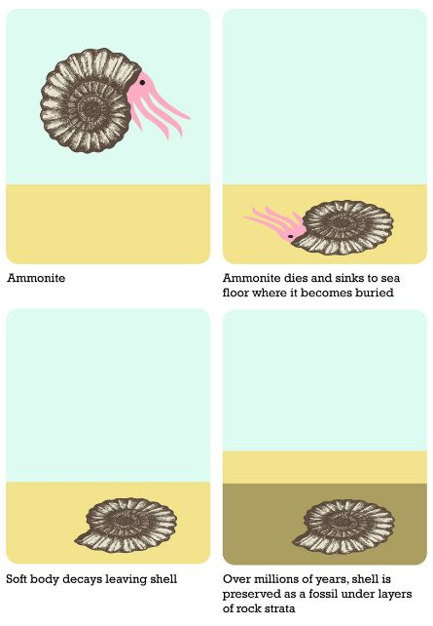
2. By 3.9 billion years ago, Earth might have cooled enough for ___________ in the atmosphere to condense. Millions of years of rainstorms filled the oceans. It is in the ______________, 3.9-3.5 billion years ago, that scientists propose the first ____________ organisms appeared.

3. ___________ evidence gives us an idea of what these early organisms looked like. A ___________ is evidence of an organism that lived long ago. Fossils are formed when organism are _______________ in small particles of soil soon after dying. The soil particles are compressed over time to form _______________________ rock.

4. A ______________fossil is a marking left by an animal (footprint, trail, burrow, etc.). A ___________ is formed when minerals in rocks fill a space left by a decayed organism to make a replica of the organism. A _______________ fossil is formed when minerals penetrate and replace the hard parts of an organism (makes copy). An _______________ fossil occurs when a thin object (leaf) falls into sediment and leaves imprint when sediment hardens. In _______________ preserved fossils, the organism quickly trapped in tree sap (also frozen in ice). A _______ fossil forms when an organism is buried in sediment and decays, leaving an empty space.

5. There are two main ways to determine the age of a fossil. ____________________ dating determines the specific age of fossils. It is based on the fact that radioactive isotopes decay at a ______________________ rate. As the elements decay, they turn in to something ________ (a new element is formed). ____________________ is the time it takes for half of the radioactive isotope to decay and turn in to something new.

6. A scientist was dating a fossil using carbon-14. If he began with 20 grams, and all that remained were 5 grams, how old is the fossil (hint: the half life of C-14 = 5730 years)

7. In __________________ dating, fossils are found in different layers of rock. The top layers are __________________ and the bottom layers are _______________. This method ____________________ determine the actual age!
8. Based on earliest observations, it was believed that life came from nonliving things, __________________ _______________________.
9. In the 1950s, American scientists ________________ and ____________ conducted experiments to determine if organic molecules could have been created from the harsh environment of early earth. They simulated early atmosphere conditions by filling a ______________ with hydrogen, methane, ammonia, and water to represent the atmosphere. Then they passed electric sparks through the mixture to simulate _____________________.

10. Over a few days several ______________ _____________ appeared! What is made up of amino acids? _____________
11. The first living organisms were _______________ and __________________, because Earth’s early atmosphere lacked oxygen. The food they consumed were small ____________________ in the early ocean. If they had to obtain their food, where they heterotrophs or autotrophs? ____________________________
12. Over time fossil evidence shows organisms evolved to survive in the presence of oxygen….but where did oxygen originate from? ___________________________ prokaryotes! These prokaryotes made their own _________, and the product of photosynthesis is ____________________. The continual production of oxygen led to the formation of the ______________ layer.
13. The rise of oxygen in the atmosphere led to the _________________________ of some life forms, while other life forms evolved new, more efficient metabolic pathways that used oxygen for __________________________.
14. The __________________________ theory proposes that eukaryotic cells arose from living communities formed by prokaryotic organisms.
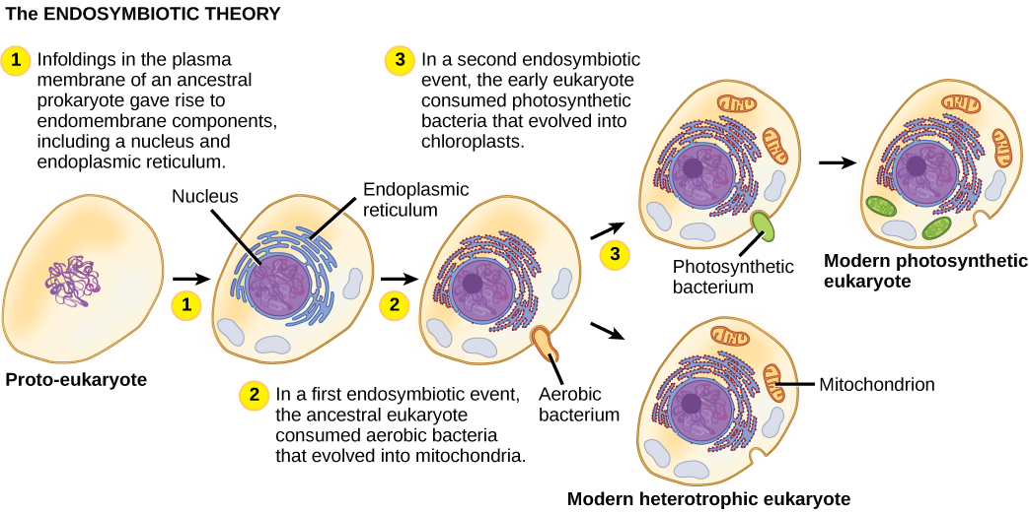
15. Evidence for the Endosymbiotic Theory comes from:
1. Mitochondria and choloroplasts contain __________ similar to bacterial DNA
2. Mitochondria and bacteria have ___________________ whose size and structure closely resembles bacteria
3. Mitochondria and bacteria _______________________ the same way – binary fission

16. Most prokaryotes reproduce ______________________ via _____________________. Sometime after eukaryotes developed, cells began to reproduce ___________________. Remember sexual reproduction (_________________) results in greater __________________ diversity and variation. Increasing the number of gene combinations ________________ the probability that favorable combinations will be produced – favorable combinations greatly _____________ the chance of evolutionary change in a species.

