ACTIVE CELL TRANSPORT GUIDED NOTES
1. There are three types of passive transport:
1. Diffusion
2. Osmosis
3. Facilitated Diffusion

All move substances ______________ the gradient from HIGH to LOW concentration ________________ using energy!

2. Some larger molecules, like _____________, cannot diffuse through the membrane because of their ______. These molecules pass through _________________ channels that facilitate (help) specific molecules pass into and out of the cell. This is called ______________________ diffusion, and does not require ____________ for motion to occur. Still diffusion, and will not occur if there is not a _________ concentration of specific molecules on one side than on the other side.
3. Sometimes cells need to move substances ________________ a concentration gradient. This process requires ____________, and is called ___________ transport. Active transport occurs when carrier proteins embedded in the membrane bind to a ________________ substance, change shape, and bring the substance into/out of the cell.
4. Cells can also bring substances in/out through the use of the cell membrane. ________________________ is the process of taking material into the cell by folding the cell membrane into a ___________________________. The pocket breaks ____________ from the membrane and forms a __________________ inside the cell.
5. Cells also _______________ and release large amounts of material from the cell in a process known as ______________________. The membrane of the ___________________ fuses with the _________ membrane and forces the contents out of the cell.

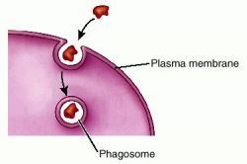
Endocytosis Exocytosis

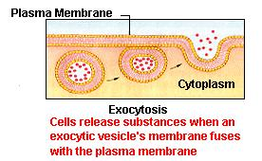

6. The human nerve cell sends messages throughout the body using the sodium (Na⁺) –potassium (K⁺) pump.
Four Step Process:
1. There is more sodium outside the cell than inside the cell. It requires energy for the cell to pump sodium out AGAINST the gradient. Sodium binds to carrier protein.
2. Energy is required to change the protein’s shape and release sodium outside of the cell.
3. Potassium binds to carrier protein.
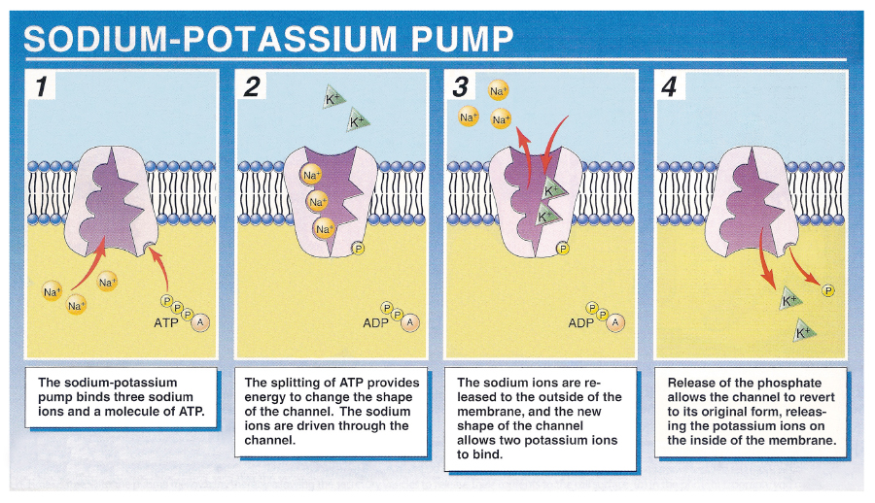
4. Energy is required to change the protein’s shape and bring potassium into the cell.

