STURCTURAL ADAPTATIONS GUIDED NOTES

1. Remember that __________________________ is about maintaining a ______________________ between the environment ______________________ your body and the environment __________________________ your body. Structural _________________________ have evolved to help animals thrive and assume ________________________ roles (niches) in even the most _________________ of environments.
2. Not all ______________________ cells have _________________________; some do, and if so they are called _________________________ vacuoles. Their purpose is to remove excess _________________ build up inside the cell.
3. The ________________________ apparatus is a photoreceptive ___________________ found in the flagellate or (motile) cells of green algae and other ________________________________ photosynthetic organisms such as ________________________ It allows the cells to sense light direction and intensity and ____________________________ to it by swimming either towards the light (positive phototaxis) or away from the light (negative phototaxis).
4. ______________________________ are long whiplike tails used for __________________ of the cell toward _________________, away from ___________________, and for __________________________.
5. ______________________ are small hairlike projections from the cell membrane used for _________________ of mucus in respiratory system and ________________________ in unicellular organisms.
Cilia Flagella
Definition | Cilia are short, hair like appendages extending from the surface of a living cell. | Flagella are long, threadlike appendages on the surface of a living cell.
Length | Short | Longer than cilia, can vary
Motion | Rotational, like a motor, very fast moving | Wave-like, undulating, sinusoidal, slow movement compared to cilia
Density | Many (hundreds) per cell | Few (less than 10) per cell
Found in | Eukaryotic cells | Eukaryotic and prokaryotic cells
Etymology | Pronounced as ‘silly-ah’, is the plural of cilium. From Latin word for eyelash. | Pronounced as ‘fla-gel-ah’, is the plural of flagellum. From Latin word for whip.
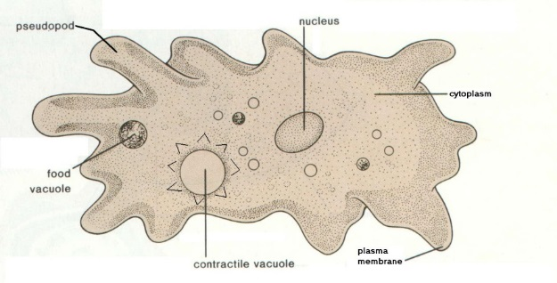
6. ______________________________ is the phenomenon whereby bacteria, and other single-cell or multicellular organisms direct their movements according to certain __________________________ in their environment. This is important for bacteria to find _____________________ (move to the greatest concentration of particles) or to move away from __________________________.
Amoebas use a pseudopod (fake foot) to move toward/away from chemicals
7. __________________________ is a kind of taxis, or locomotory ______________________, that occurs when a whole organism moves in _______________________ to the stimulus of ____________________. This is advantageous for phototrophic organisms as they can orient themselves most efficiently to receive light for _________________________________. Phototaxis is called ___________________ if the movement is in the direction of increasing light intensity and _____________________ if the direction is opposite.

