Biochemistry Review Sheet

- On the enzyme cut out activity, what did you notice about the enzyme from the beginning of the reaction to the end?

- Describe the relationship between a monomer and a polymer and give an example from one of the macromolecules in the chart.

- What is a monosaccharide – protein, lipid, carbohydrate, or nucleic acid?

- Which organic compounds serve as the main source of energy in organisms?

- What type of biomolecule has a special shape for its special function?

- Compare proteins and nucleic acids. How are they alike?

- Compare carbohydrates and lipids. How are they alike?

8. What is the term for the energy used to get a reaction started?

9. What are some characteristics of enzymes?

10. What are the solutions used to test nutrients, what nutrients do they test for, and what are the appearances of positive tests for those nutrients?

11. What molecule is used to store glucose in plants?

12. What molecule is used to store glucose in animals?

13. What is the function of cellulose in plants?

14. What is the function of chitin in animals?

14. What type of macromolecule are glycogen, starch, cellulose, and glucose?

15. What is the process of maintaining internal balance called?

16. What type of biomolecule is insulin? What is the function of insulin?

17. What type of molecule is hemoglobin? What is the function of hemoglobin?

18. Which graph uses an enzyme? How do you know? What does Ea mean?

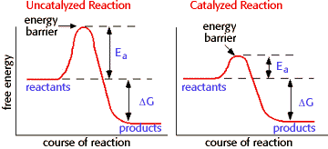

19. What two factors can affect how enzymes work?

20. What happens to an enzyme when it becomes denatured?

21. Label the diagrams below with the following terms:
products, substrate, enzyme, enzyme-substrate complex, active site

