Standard 1 Packet
Biology Essential Standard 1.1, 1.2 and 1.3
Understand the relationship between the structures and functions of cells and their organelles.

Bio.1.1.1 Summarize the structure and function of organelles in eukaryotic cells:
- Match these organelles with their functions:
  - Nucleus 1. Sites of photosynthesis, contain chlorophyll.
  - Plasma Membrane 2. Powerhouse of the cell, where cell respiration occurs.
  - Cell Wall 3. Brain of the cell, contains the DNA & chromosomes.
  - Mitochondria 4. Sites of protein synthesis, where mRNA & tRNA meet.
  - Vacuoles 5. Cell’s outer boundary, lipids & proteins, semipermeable.
  - Chloroplasts 6. Found in plants only to maintain structure, not semipermeable.
  - Ribosomes 7. Large in plants, small in animals, used for storage.

- Determine which cell is an animal and which is a plant cell. Label the organelles in the cells:

Ribosome, Nucleus, Mitochondria, Cell Wall, Plasma Membrane, Vacuole, Chloroplast

Cell A:____________________ Cell B: ____________________
1._______________________ 1.______________________
2._______________________ 2.______________________
3._______________________ 3.______________________
4._______________________ 4. ______________________
5. ______________________
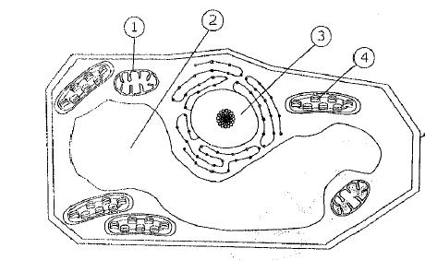
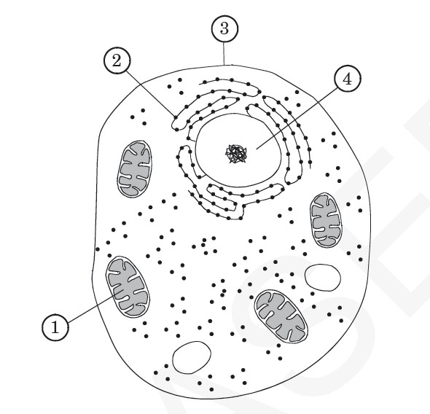
5
Cell B
Cell A

- What three things do plant cells have that animal cells do not?

b.
c.

Bio 1.1.3 Explain how instructions in DNA lead to cell differentiation and result in cells specialized to perform specific functions in multicellular organisms.

- Compare a variety of specialized cells and understand how the functions of these cells vary:
Match these cells with their functions:
  - nerve cells 1. Vascular tissue in plants that carry water.
  - muscle cells 2. Vascular cells that carry oxygen & nutrients & fight disease.
  - blood cells 3. Cells which send impulses back and forth to brain and spinal cord.
  - sperm cells 4. The male gamete.
  - xylem 5. Vascular tissue in plants that carry food.
  - phloem 6. Cells which flex & extend (contract) to allow movement.
  - Bone cells 7. Cells that form a supporting framework for the body; where adult stem cells are found
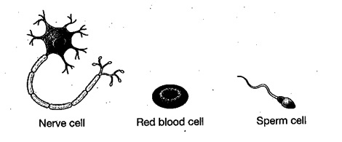
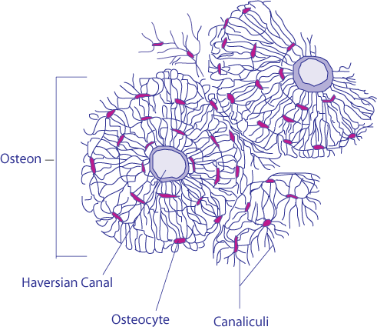
D

C
B
A

Word Bank:
Undifferentiated, DNA, gene, differentiation, identical, mitochondria, chloroplast, nerve cells, differentiated, stem cells

- Multicellular organisms begin as _____________________________masses of cells and variation in ____________ expression and ____________activity determines the differentiation of cells and ultimately their specialization.
- Cells that have not differentiated into various cell types are called ___________ ___________.
- Muscle cells require a lot of energy, therefore, they must have many __________________.
- Palisade mesophyll cells in leaves are responsible for photosynthesis. They have a lot of which type of organelle? ______________________
- _________________________ transmit signals throughout the bod and have a long, slender shape.
- All cells in an organism contain ______________ DNA, yet some cells have specialized functions. Cells gain their specialization when genes are turned on or off during _____________________.

Prokaryote | Eukaryote
Membrane bound organelles | Ribosomes
Only bacteria | DNA
DNA | Nucleus
Plants | Animals
Simple internal organization | Plasmid
Complex internal organization | Larger sized
Complex cell wall structure | Ribosomes
Humans | Smaller sized
First cells | Protists
Sperm | Genetic diversity
Produces clones | Main purpose is growth
Plasma membrane or simple cell wall

Membrane-bound organelles Ribosomes
Only bacteria DNA
DNA Nucleus
Plants Animals
Simple organization Plasmid
Complex organization Large sized
Complex cell wall structure Ribosomes
Humans Small sized
First cells Protists
Plasma membrane or simple cell wall

Bio.1.2.3 Explain how specific cell adaptations help cells survive (focus on unicellular organisms).
11. Identify the cells below:
Amoeba, paramecium, euglena, prokaryote

A. _______________ B. ________________ C.___________________ D.__________________

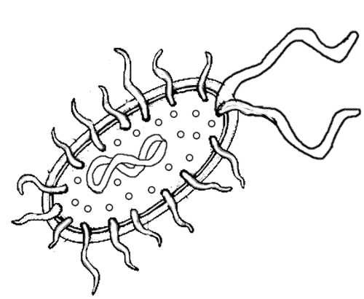
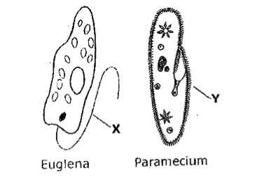
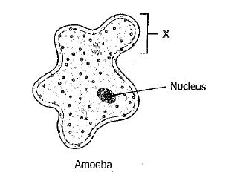

Label the following parts on the cells above: plasmid, cilia, eye spot, pseudopod, contractile vacuole, flagella (used twice)

Bio.1.2.3 Explain how specific cell adaptations help cells survive in particular environments (focus on unicellular organisms).

- Explain how various structures of unicellular organisms help that organism survive and list an organism that has these structures: (match each with their definition/examples):
 | Long whip-like tails that are used in locomotion | Extensions of the cytoplasm that are used in locomotion & nutrition. | A photo-sensitive area that detects light. | Pump excess water out of the cell. | Tiny hair-like projections that are used in locomotion & nutrition
Contractile vacuoles
Cilia
flagella
pseudopods
eyespots

 | Euglena, sperm cells | Paramecium, cells that line our respiratory system | Amoeba, some white blood cells | These allow euglena to be autotrophic and heterotrophic | Found in many unicellular organisms such as paramecium to help maintain osmotic balance
Contractile vacuoles
Cilia
flagella
pseudopods
eyespots

- Summarize adaptive behaviors of cells and give an example of each: (match)
  - chemotaxis 1. A movement toward/away from light
  - phototaxis. 2. A movement toward/away from food molecules, poisons, etc.

Biology Essential Standard 1.2: Analyze the cell as a living system.

Bio.1.2.1 Explain how homeostasis is maintained in a cell and within an organism in various environments (including temperature and pH).

- Label the pH Scale with: neutral, strong acid, strong base, weak acid, weak base

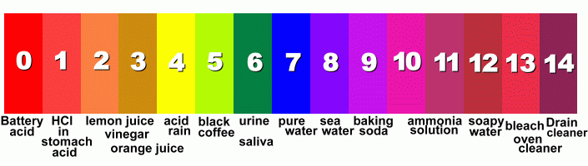
  - High pH (big number) means that it is a strong {acid or base?}. ____________
  - Low pH (small number) means that it is a strong {acid or base?}. ____________
  - A(n) (enzyme, buffer, acid or base)_________________________ is used to maintain a constant pH in the internal environment of a cell so enzymes in the cell will function well & chemical reactions will take place at normal rates. This is an example of the need for maintaining homeostasis.

OSMOSIS
- Label the pictures below ( isotonic, hypertonic, or hypotonic environments)
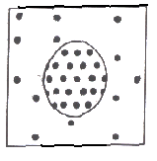 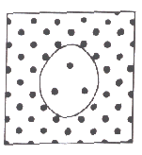 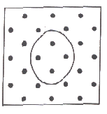
_________________ __________________ _________________

- Explain changes in osmotic pressure that occurs when cells are placed in solutions of differing concentrations. Can you describe what happens to cells in those different solutions:
 | Isotonic | Hypotonic | Hypertonic
Cells placed in this solution do not change in size.
Cells placed in this type of solution shrink.
High osmotic pressure inside the cell (lower pressure outside the cell)
Low osmotic pressure inside the cell (higher pressure outside the cell)
A red blood cell placed in salt water.
A red blood cell placed in distilled water.

Bio.1.2.2 Analyze how cells grow and reproduce in terms of interphase, mitosis and cytokinesis.
- Place these 5 steps of the cell cycle in order: (they are NOT in order):
  - Cytokinesis, Growth1 (G1), Mitosis, Growth2 (G2), Synthesis (S)

- Which type of reproduction uses mitosis to form the cells?

- Label the PHASES and the parts of these cells in the process of mitosis and describe what is occurring in each phase.

Phase: _________ _________ _________ _________
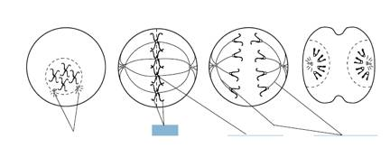

Mitosis | Meiosis

Produces 4 cells | Skin cells
Gametes | Interphase
Eggs | Produces 2 cells
Diploid | Goes through PMAT once
Trisomy 21 - nondisjunction | Crossing over
Goes through PMAT twice | Haploid
Interphase | Somatic cells
Homologous Pairs | Asexual
Sperm | Genetic diversity
Produces clones | Main purpose is growth

Label the diagram below with the following labels:
Anaphase G2 Mitosis
Cell Division (mitosis) Interphase Prophase
Cytokinesis Interphase S (Synthesis) Phase
G1 Interphase Telophase
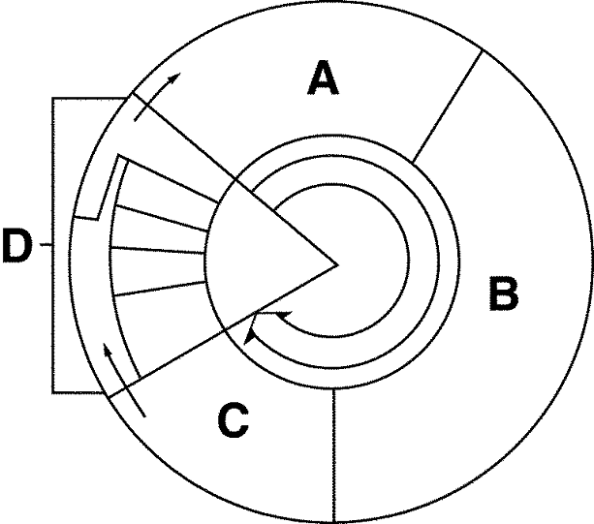

A.___________________________________________
B. ____________________________________________
I.
C. ____________________________________________
D. ____________________________________________
H.
E. ____________________________________________
G.
F. ____________________________________________
F.
G. ____________________________________________
J
H. ____________________________________________
E
E
I. ____________________________________________
J. ____________________________________________

Match the purpose with the correct stage of the cell cycle. You may use some more than once.

A.Interphase B. Prophase C. Metaphase D. Anaphase E. Telophase F. Cytokinesis G. G1 H. G2 I. S

_____ 20. Stage that lasts the longest.
_____ 21. Stage (s) that make up Interphase.
_____22. Stage where DNA Replication occurs.
_____ 23. Stage when the cell prepares for mitosis.
_____ 24. Stage where chromosomes line up along the equator.
_____ 25. Stage where chromosomes thicken and condense; first time you can see the chromosomes
_____ 26. Stage where chromosomes are pulled apart into chromatids
_____ 27. Stage when the cell plate (plants) or cleavage furrow (animals) form
_____ 28. Stage when the cell grows.
_____ 29. Stages that make up mitosis.
_____ 30. Stage when cytoplasm is equally dispersed between the cells.
_____ 31. Stages not included in mitosis.

32. What would happen if the spindle fibers did not work properly during mitosis?
a. the chromosomes will fail to separate properly
b. one cell could have too much genetic material (trisomy)
c. one cell could have too little genetic material (monosomy)
d. all of the above

33. What would happen if the cytokinesis phase did not occur?
  - There would be no nucleus
  - There would be no cytoplasm
  - There would be more than one nucleus
  - There would be no genetic material in the new cell

