Your blood type is established before you are BORN, by specific __________ inherited from your parents. You inherit one gene from your _______ and one gene from your _________. These genes determine your blood type by causing proteins called __________________________________ to exist on the surface of all of your red blood cells.
Multiple Alleles – having 3 or more alleles for the same gene in a population, HOWEVER any given individual can have only ______ of these alleles; Ex: coat color in rabbits and A, B, AB, O blood types
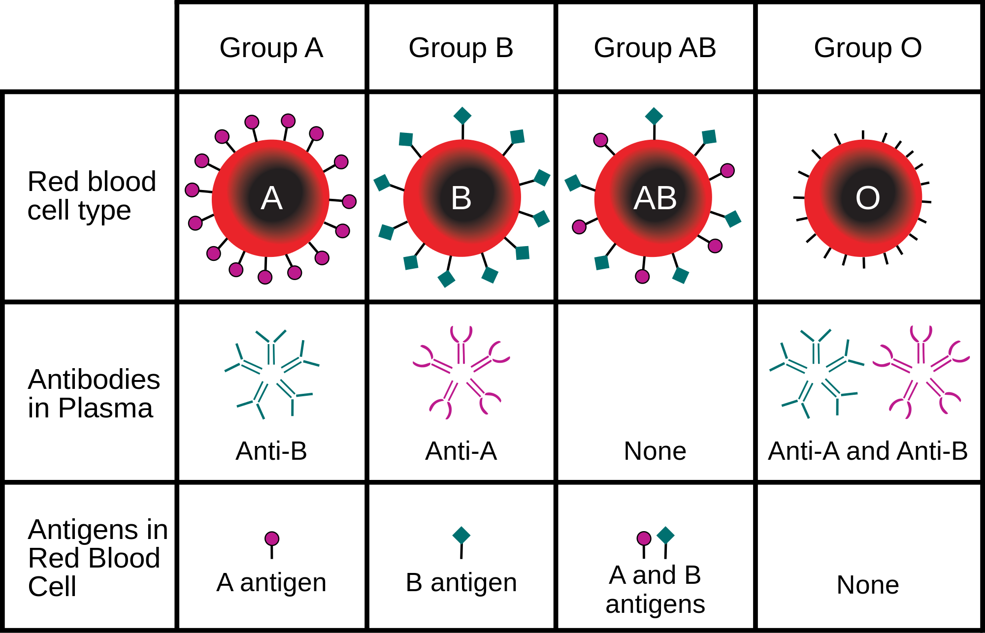There are _____ alleles of the gene that control blood type: I^{A}, I^{B}, i. The “I” stands for ________________________, or the type of white blood cell that would be triggered to attack. I^{A} and I^{B} are ________________________ genes, meaning when inherited together, they are both fully expressed, not blended, as in Incomplete Dominance. “ i ” is the ____________________ form of the allele. Type O blood is a recessive trait, therefore ________ recessive genes must be inherited to have the O blood type.

GENOTYPE | I^{A}I^{A} or I^{A}i  (AA or AO) | I^{B}I^{B} or I^{B}i  (BB or BO) | I^{A}I^{B}  (AB) | ii  (OO)
CAN DONATE BLOOD TO | A, AB | B, AB | AB | A, B, AB, O
CAN RECEIVE BLOOD FROM | A, O | B, O | A, B, AB, and O | O

Sample Problem:
Alice has heterozygous type A blood and her husband Mark has homozygous type B blood. What percentage of their offspring would have type AB blood?

Alice’s genotype: _________ Mark’s genotype: ____________

% A: ______________ % AB: _____________

% B: ______________ % O: ______________

