Carbon Compounds Guided Notes

1. All living things are made up of chemical _________________________. The smallest unit of all things is the _________________. Atoms are composed of _____________________ and _______________________ found in the nucleus, and ________________________ found in energy levels around the nucleus.

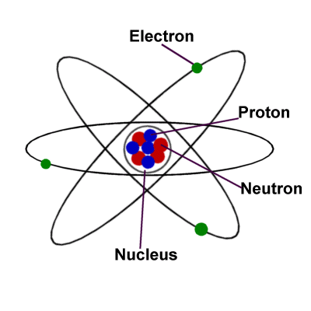
2. Electrons in the last, or outermost energy level, are important for forming __________________ between other atoms. A substance consisting of only one type of atom is an ________________________. Lots of bonds between different types of atoms are called ________________________________.
3. ________________________________ are pure substances that are made of the same type of atom. EX: Carbon (C), Hydrogen (H), Oxygen (O), Nitrogen (N), Phosphorus (P).
One of the most important elements to living things is ________________________.

4. Carbon is unique. It can:
(1) Form 4 ___________________ with many different elements
(2) Can bond to other carbon atoms, giving it the ability to form ______________________ almost unlimited in length
(3) Can form bonds of different _________________________ (single, double, triple bonds)
(4) Is extremely _______________________ (can form millions of different large and complex structures)
(5) is abundant – there’s lots of it!

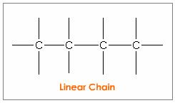
5. Carbon can bond with up to four other __________________. Carbon has 4 (outermost) electrons that can be shared with other elements. This allows it to ___________________ with 4 other atoms.

6. Carbon ____________________ readily with itself. This allows carbon to be the ____________________________ of large and complex molecules. Carbon bonds readily with other elements - in living things: Sulfur, Phosphorus, Oxygen, Nitrogen, & Hydrogen (_________________________)

7. Carbon bonds to build a variety of _____________________ including straight chains, branched chains and ___________________.
8. Carbon forms bonds of different _____________________ including single, double and triple ___________________.

9. ____________________________ are substances made up of different elements EX: Water (H₂O), Glucose (C₆H₁₂O₆), Carbon Dioxide (CO₂). Molecules are examples of _________________________, single building blocks that are joined together to make polymers.

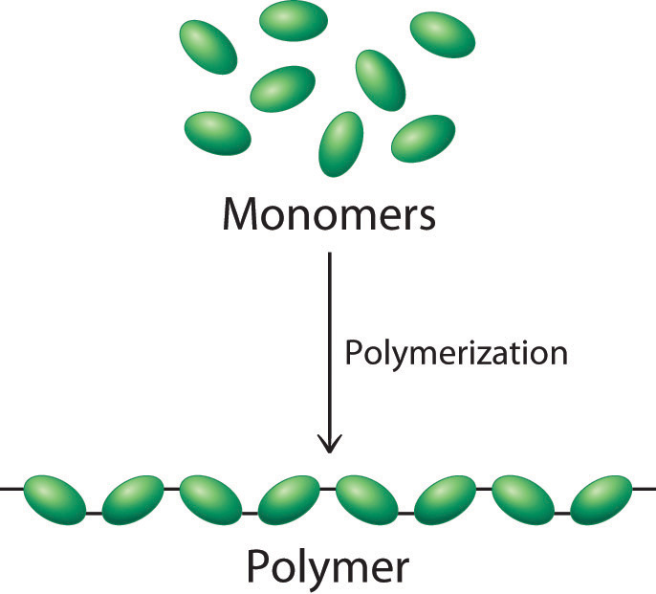
10. _____________________________ are macromolecules. Macromolecules – “giant molecules” made from thousands or hundreds of thousands of smaller molecules. Formed through a process called _______________________________. Smaller units (_____________________) join together to make larger, longer units (_______________________).

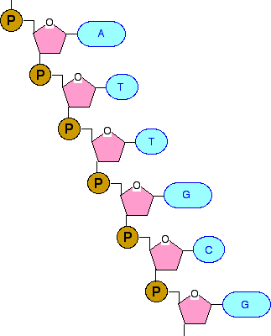
11. Polymerization is similar to stringing beads on a necklace. ________________________ are represented by beads and the ____________________________ is represented by the necklace. Monomers can be the same, or different.

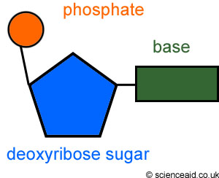
12. —Four types of biomolecules:
(1) Carbohydrates – sugars and starches
(2) Lipids – fats and oils
(3) Proteins – enzymes
(4) Nucleic Acids – DNA, RNA, ATP, ADP

13. Each type of biomolecule has its own monomer unit
Biomolecule (polymer) | Monomer

Polymer

