Cell Cycle Review Summarization
1. ____________________________ is a series of events a cell goes through as it grows and divides.

2. Humans have _____ total chromosomes, or _____ pairs of chromosomes. Chromosomes pass genetic material from one generation to the next. You get one pair of chromosomes from your _______ and one pair of chromosomes from your _______.

3. Label the following on the picture below: centromere, chromosome, sister chromatids
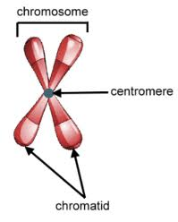
4. Mitosis is an example of ____________________ reproduction.

5. Mitosis begins with _____ “parent” cell and ends with _____ new
“daughter” cells that are genetically _______________ to the parent.

6. Only _________ cells reproduce via mitosis. Examples of somatic cells include: muscle, blood, bone, and skin cells.

7. The purpose of mitosis in multicellular organisms is _________________ and ____________ of damaged tissues. The purpose of mitosis in unicellular organisms is _____________________________.

8. The cell cycle consists of three main phases:
1. _________________________ - which includes the G1, S, and G2 stages
2. _________________________ - which is when the nucleus of the cell divides
3. ________________________ - which is when the cytoplasm of the cell divides

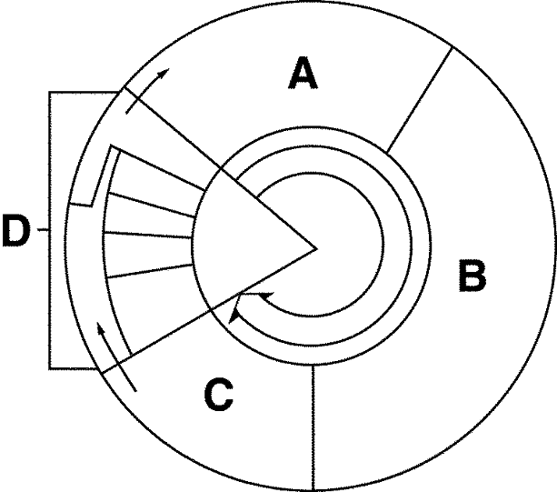
9. Label the cell cycle below with the following: Mitosis, S phase, Cytokinesis, Anaphase, Metaphase, G1 phase, Telophase, G2 phase, Prophase,

10. List the phases of Interphase and what happens in each.

11. List the four phases of Mitosis, and summarize what happens in each.

12. What happens during cytokinesis?

13. What is the difference between an animal cell’s telophase and a plant cell’s telophase? Draw a picture and explain.

