Cell Differentiation Notes

1. Do all ________________________ cells look the same? __________! Cells can _____________________________ to perform different functions.
Nerve Cell
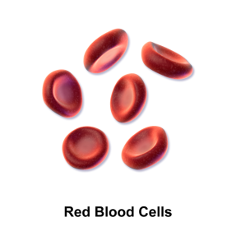
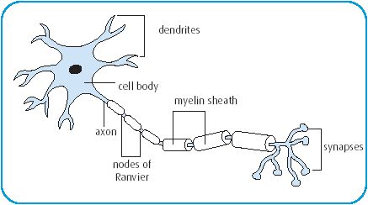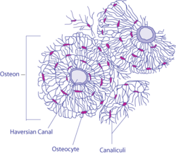
Bone Cell
2. Red blood cells function to transport ____________ and remove carbon dioxide and waste products from cells. Muscle cells function to allow _________________ to occur. Nerve cells have the ability to conduct __________________ impulses to maintain _______________________ in the body. Bone function to provide ___________________________ and ______________________________.

