Cell Differentiation Notes

1. Do all ____________________ cells look the same? ______! Cells can _______________________ to perform different functions.
Nerve Cell
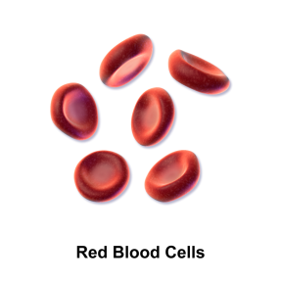
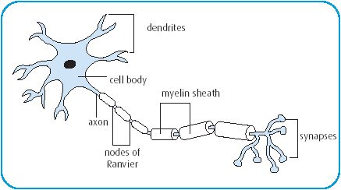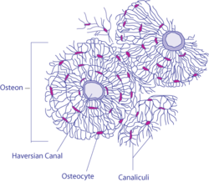
Bone Cells
Red Blood Cells

2. ______________________________________________ is the process of a __________________ changing from a less specialized type becoming a more specialized type.
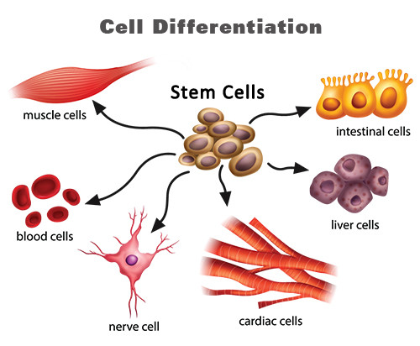
3. Although each ________________________________ (body) cell has the same DNA, only specific parts of the DNA are _________________________________________. The parts of the DNA that are activated determine the ___________________________ and specialized _______________________________________ of a cell.
4. Because all cells contain the same DNA, all cells initially have the __________________________________ to become any type of cell; however; once a cell differentiates, the process cannot be reversed.
5. Red blood cells function to transport ____________ and remove carbon dioxide and waste products from cells. Muscle cells function to allow _________________ to occur. Nerve cells have the ability to conduct __________________ impulses to maintain _______________________ in the body. Bone function to provide ___________________________ and ______________________________.

Watch the Amoeba Sisters Video about Cell Differentiation:
http://tinyurl.com/gou2yom

