Cell Growth and Reproduction Guided Notes

1. Two reasons _________________ cannot continue to grow larger __________________________________________:
(a) The larger a cell becomes, the more _________________________ the cell places on its DNA. As cell gets bigger, it does not make extra copies of ______________________.
(b) Cell has more trouble moving enough _____________________ and wastes across the cell membrane.

2. Before it becomes too large, a growing cell _______________________ forming two “______________________” cells. The process by which a cell ____________________________ into two new daughter cells is called _______________ ______________________________.
3. The ____________ ________________ is a series of events a cell goes through as it grows and divides.

4. Before the cell _______________________, it must first copy its _________________________________ information.
Two stages for cell division:
(1) ____________________________ – division of the nucleus
(2) ______________________________________ – division of the cytoplasm

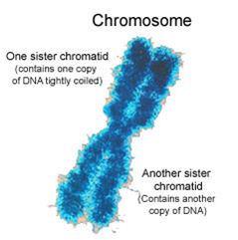
5. Reproduction by mitosis is _______________________, because the daughter cells are ___________________________ identical to the parent cell.

6. Chromosomes are composed of DNA and proteins and pass ___________________________ information from one ____________________________ to the next. Humans have _____________ chromosomes. (23 pairs). One of each pair from mom and one from dad

7. Chromosomes are visible only during cell _________________________, when they ___________________________ into compact, tightly coiled structures.

8. Before cell division occurs, each ____________________________________ is replicated or _______________________. Because of this, each chromosome has two identical “_________________________” chromatids. When the cell divides the ____________________ _______________________________ separate from each other, so that one ________________________________________ goes into each of the new ________________________.

9. In humans, only chromosome pairs 1-22 reproduce via ___________________, because these chromosomes include somatic (body) cells. Examples of ________________________ cells include: muscle, blood, bone, and skin cells.

10. The purpose of mitosis in multicellular organisms is ____________________ and ___________________ of damaged tissues. The purpose of mitosis in unicellular organisms is replication (creating a new organism).

11. The __________________ ________________________ is the series of events that cells go through as they _______________________ and _________________. Consists of 4 phases:
1. M phase – _________________________ and cytokinesis
2. _________ phase – chromosome replication
3. G1 and G2 phases – “____________________” of time with intense _________________________ and activity
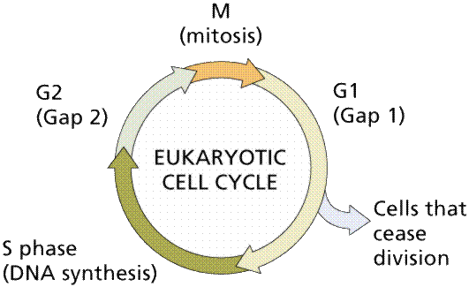
12. Interphase consists of three phases:
a. G1 phase
b. S phase
c. G2 phase

13. The _________ phase is a period of activity in which cells do most of their ___________________. Cells _____________________ in size and synthesize new __________________ and organelles.

14. The ___________ phase is a period in which _______________________________ are replicated and the synthesis of DNA (DNA replication) occurs.

15. The ____________ phase is the shortest of the three phases of _________________________________. Many organelles and molecules required for ____________ ______________________ are produced. When G2 phase is over, cell is ready to enter _______________- phase and begin cell division.

16. Mitosis is the time of cell ________________________________. Mitosis process can last from a few minutes to several days. Four phases included:
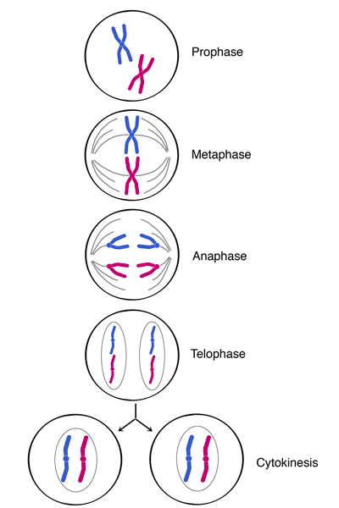
a. Prophase
b. Metaphase
c. Anaphase
d. Telephase

17. Prophase is the longest phase of mitosis.
a. _____________________ condenses into chromosomes. b.____________ ___________________ dissolves.
c. ________________________ move to poles.
d. ________________________ fibers form

- Centromere = Center of ___________________________
- _________________________ = organize spindle, that will help separate chromosomes during division
- Spindle = microtubules that guide __________________________

18. Metaphase is a short phase. Chromosomes line up at the _____________________. Microtubules connect centromere to ________________________.
19. During _____________________, centromeres split and sister ______________________ separate to become individual __________________________.

20. During telophase, chromosomes ___________________________ and the nucleus reappears.

21. Cytokinesis = division of ______________________ making 2 new daughter cells
a. Animal cells
    - Plasma membrane pinches along _________________________________
    - Forms 2 new cells
b. Plant Cells
    - Cell _______________________ laid across ______________________________
    - Cell membrane forms around each cell
    - New _________________ _________________________ form

22. Results of mitosis:
- 2 new cells with identical chromosomes as parent cell
- Unicellular organisms
- Organism multiplied
- Multicellular organisms
- Cell growth and reproduction
- Tissue – groups of cells that work together
- Organs – tissues organize in various combos
- Organ Systems – multiple organs

23. Cancer - ________________________________ growth resulting from _________________________________ cell division
a. May be caused by ______________________________ factors or by changes of enzyme production
b. Genes are segments of __________________ that control the production of a ____________________ portion just before DNA _________________________. This is the key ____________________ period.

24. Cancer is a mistake in the _________________ _____________________.
- Form masses of tissues called _____________________ – deprive normal cells of nutrients
- ____________________________ cells enter circulatory system and spread – form new tumors
- 2nd leading cause of death
- 1st is heart disease

25. Genetic and environmental factors
- Different countries different types
- Environmental:
- Cigarette smoke
b. Air and water pollution
c. UV rays
d. Viral infections

26. Cancer prevention includes a life healthy lifestyle
  - Diets low in fat and high in fiber
  - Fruits, veggies, grain products
  - Vitamins and minerals
    - A,C,E, Calcium
  - Exercise

