EUKARYOTIC CELL STRUCTURE GUIDED NOTES

1. Many structures in eukaryotic cells act like specialized ______________, and are called ________________________ “little organs”. There are two major divisions in the structure of eukaryotic cells: the ______________ and _______________________.
2. The ___________________ contains genetic information (_______), and with it the coded instructions for making _____________________ and other important molecules.
3. The nucleus also contains _______________________, the granular material you can see in the nucleus. Chromatin is composed of ______ bound to protein. When it is time for the cell to divide (reproduce), chromatin condenses to form _________________________. Chromosomes are thread-like _____________________ material that is passed from one generation of cells to the next.
4. The __________________ is the portion of the cell outside the nucleus. The organelles are found _____________________ in the cytoplasm. The function of the cytoplasm is to _________________ materials within the cell and into and out from the cell.
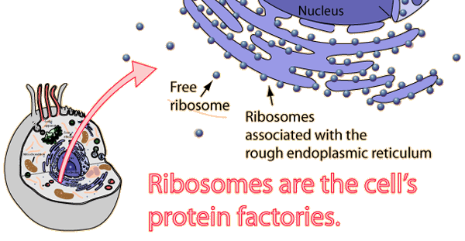
5. _____________________ are small particles of RNA and protein found throughout the cytoplasm. They function to produce ________________ by following a set of instructions received from the nucleus.
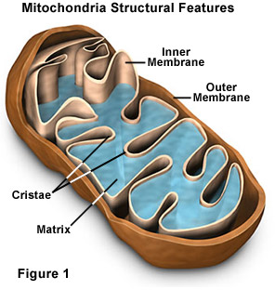
6. ______________________ are saclike structures used to store materials like water, salts, proteins, and carbohydrates. They are most common in ________________ cells, where the pressure of the vacuole makes it possible to _______________ leaves and flowers. In animals, the vacuole is used to pump ________________ water out from the cell. They are then called _______________________ vacuoles.
7. ________________________________ function to provide energy for the cell. They convert ________________ energy stored in food (glucose) into a form that the cell can use. Inherited from _______________ only! Mitochondria are often found in ________________ cells. Notice the increased number of folds (____________) found inside the mitochondria. This increases the _______________ ___________ available for converting “food” into energy the cell uses.
8. In plant cells, ______________________ use light energy to perform __________________________________. Chloroplasts also contain their own _____________. Chloroplasts also contain green pigment called _________________________ that gives plants their green color.

Animal Cell | Plant Cell
Cell ____________________ surrounds cell | Cell wall made of _______________________ surrounds the cell
___________________ occupies most of the space in the cell. | ____________________ is pushed to the sides of the cell.
Rarely contains ____________________. If so, they are small and temporary. | Vacuole takes up majority of _____________ of the cell.
Stores reserve energy in form of __________________. | Stores reserve energy in form of ____________________.
9. Remember ____________________________ cells include animals AND plant cells! Animal and plant cells contain a cell __________________________ that controls what enters and leaves the cell. Only plant cells have a rigid ________ ______________ made of cellulose to protect the cell from harm and provide rigid support of leaf and stem structures.

