C
H
A
L
L
E
N
G
E
R

S
N
A
C
K
:

D
i
c
h
o
t
o
m
o
u
s

K
e
y
I
d
e
n
t
i
f
i
c
a
t
i
o
n

On the next page, you will see 12 different alien creatures. Use the Creature
Identification Key to identify the aliens. Write the names of the alien creatures in the blanks at the bottom of this page. Note: These funny aliens with funny names are
fictitious. At this time, there has not been alien life identified on Mars.

CREATURE IDENTIFICATION KEY

- Does it stand or walk on its legs? 7. Does it have POINTED EARS?
If YES, go to question #6. If YES, the alien is a BELZARK.
If NO, go to question #2. If NO, go to question #8.

- Does it have spots on its skin? 8. Does it walk on 6 LEGS?
If YES, the alien is a SNERF. If YES, the alien is a RUDARG.
If NO, go to question #3. If NO, go to question #9.

- Does it have stripes on its skin? 9. Does it have WINGS?
If YES, the alien is a GORZAK. If YES, the alien is a SCHMELK.
If NO, go to question #4. If NO, go to question #10.

- Does it have 4 Legs? 10. Does it have THREE EYES?
If YES, the alien is a MOG. If YES, the alien is a SNOOF.
If NO, go to question #5. If NO, go to question #11.

- Does it have a FORKED TONGUE? 11. Does it have FINGERS AND TOES? If YES, the alien is a BEM. If YES, the alien is a POG.
If NO, go to question #6. If NO, go to question #12.

- Does it have HAIR on its back and head? 12. Does it have sharp POINTED TEETH? If YES, the alien is a WABBLER. If YES, the alien is a BIZZLE.
If NO, go to question #7. If NO, the alien is a YAZBAT.

1. __________________ 2__________________ 3 __________________

4. __________________ 5__________________ 6. __________________

7. __________________ 8__________________ 9. __________________

10. __________________ 11_________________ 12. _________________
1  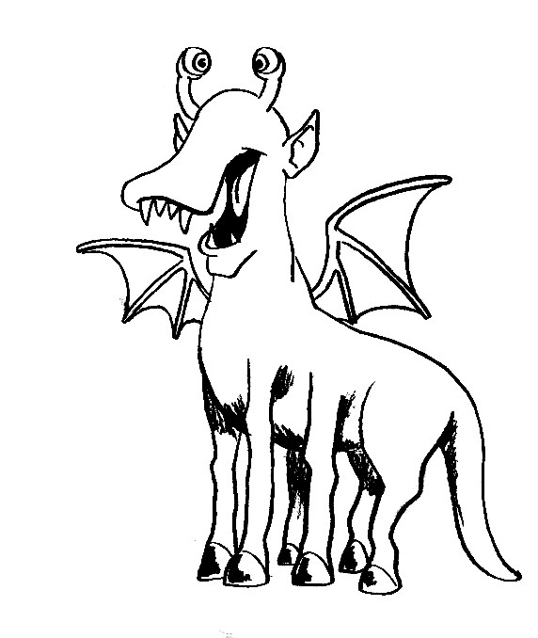 | 2  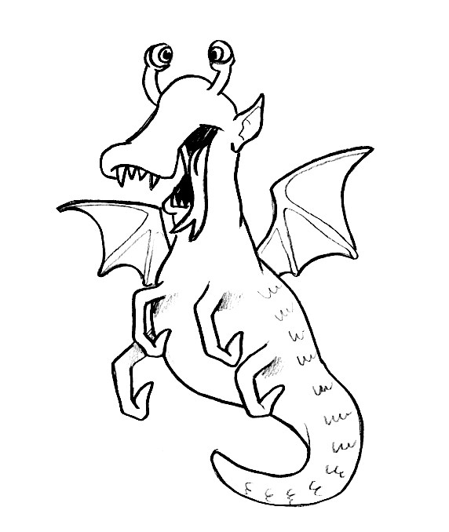 | 3  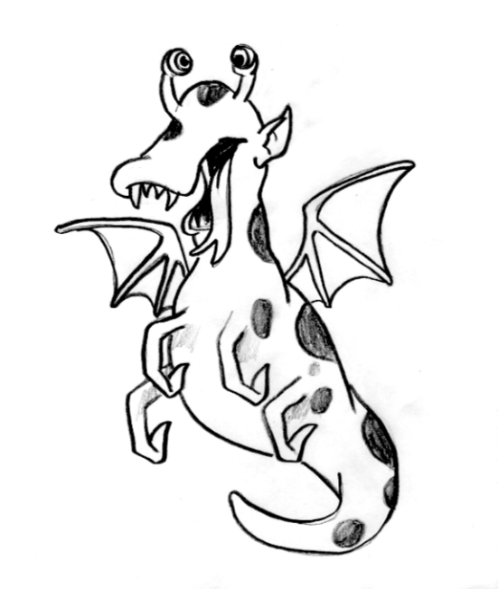
4  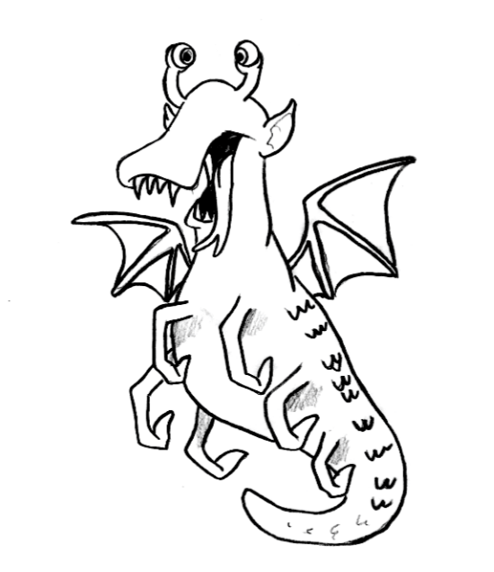 | 5  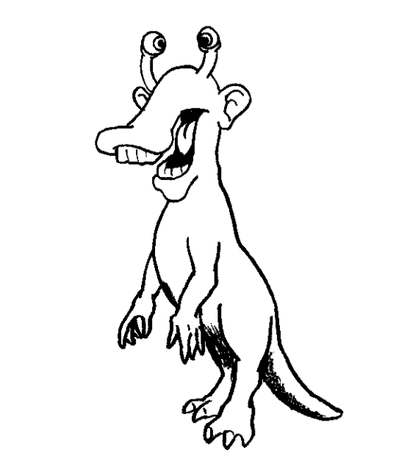 | 6  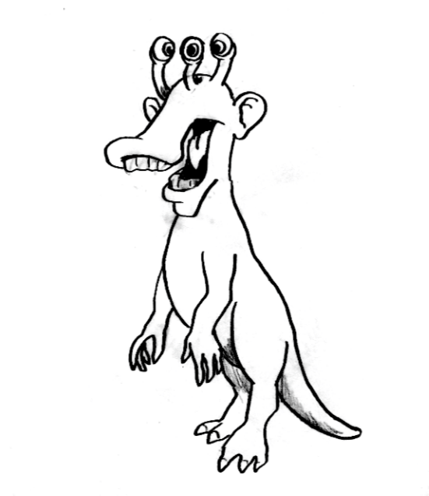
7  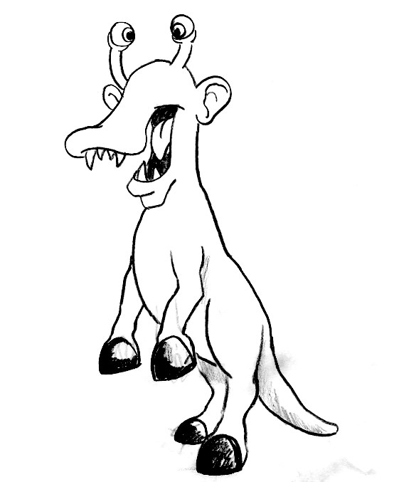 | 8  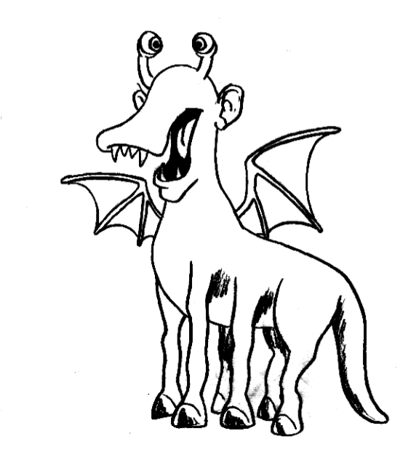 | 9  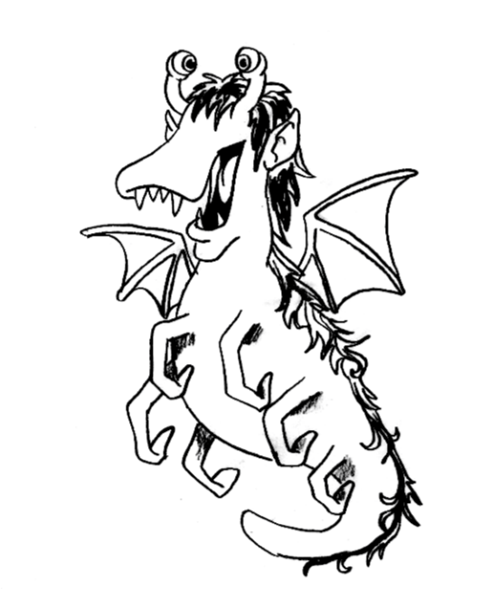
10  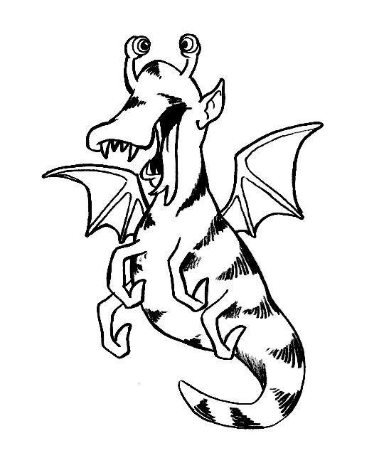 | 11  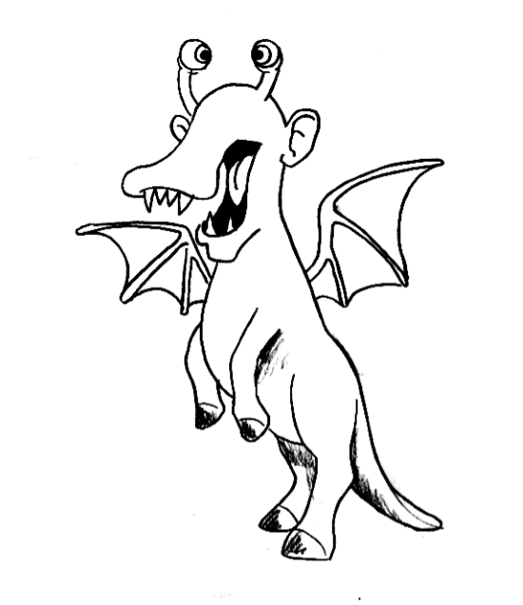 | 12  