DNA Fingerprinting Review
1. What is DNA fingerprinting, and why is it a good process to use to identify an individual?

2. What are some reasons why we would want to compare DNA?

3. Steps of DNA fingerprinting:
(1) _____ DNA into fragments using _______________________ __________________ from bacteria. These
enzymes cut DNA at specific _____________________ sequences.

(2) Separate the fragments of DNA by using _____ _____________________________.
These fragments are _________________ These fragments are _________________

This side is _____ charged. This side is _____ charged.

*DNA has a ___ charge. It is
electrically attracted to the
opposite end of the gel

(3) ______________ the DNA fragments with other DNA samples. Remember that half of your DNA comes from
your _________________ and half of your DNA comes from your _____________________.

4. Is the man the father?
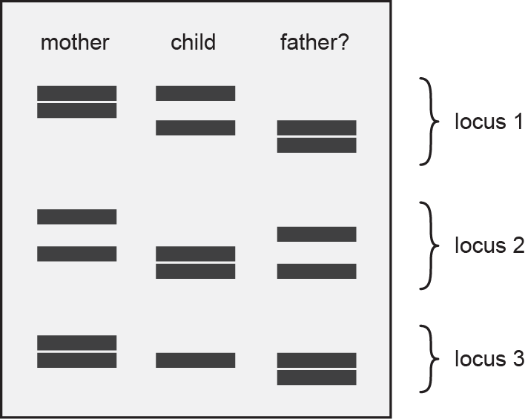
5. Who committed the crime?
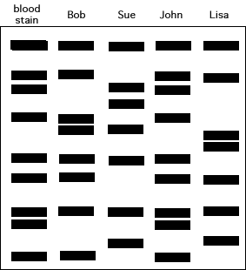

6. Is the man the father?
Father
Child
Mother

