Enzymes Guided Notes
1. ___________________ are proteins that aid in biochemical reactions. Most chemical reactions require energy to begin. The energy required to start a chemical reaction is called _________________________ energy.
2. Enzymes are _____________________ which reduce the _________________________ _____________________ required for a chemical reaction to occur.
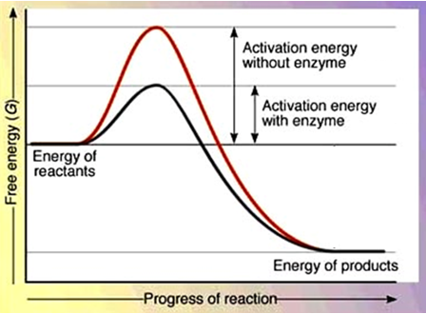
3. Enzymes are often referred to as ____________________ because they speed up chemical reactions. The catalyst does not _______________ during the reaction!
4. Enzymes have an area called an _____________ site. The active site is where the ____________________ reaction occurs.
5. The active site of the enzyme fits with only one type of molecule known as the _______________________. The fact that the active site can only accept ________ type of substrate is known as _________________ specificity.
6. Enzymes are affected by two main factors:
(1) ____________
(2)______________________
7. Each enzyme functions best within a certain _________ range. For example, the enzyme ________________, which works in your stomach, functions best in a strongly __________________ environment. When the pH changes, the active site __________________ and _________________ enzyme function.
8. Chemical reactions ________________ up as temperature is _____________________, so, in general, reactions will increase at a ________________ rate at ____________________ temperatures. However, each enzyme has a temperature _________________________, and beyond this point the enzyme's _____________________ shape is lost. Boiling temperatures will ___________________ most enzymes.
9. Enzymes often end in the suffix ___________. EX: Amylase - breaks down ______________, Catalase – breaks down H₂O_{2,} DNA polymerase – joins DNA nucleotides to build DNA, Lipase – break apart ________, Lactase – breaks apart ________________ (milk sugar), Protease- breaks apart ________________ molecules.

