Guided Notes: Principles of Ecology

1. Ecology is the study of _________________ that occur between organisms and their ___________________________.
2. Recall that the _______________ includes all living things. In order to better understand the biosphere, we must first understand how living things are affected by nonliving (________________) and living (_________________) things present in their environment.
3. ___________________ factors are the nonliving parts of the environment. EX: temperature, _____________, light, soil. Why should we include these factors when studying living things?
4. ___________________ factors are living things that inhabit an environment. All __________________ depend on other living things directly or indirectly for: food, ________________________, reproduction, or protection.
5. To help ecologists study the ____________________ of the biotic and abiotic parts of the world, they have organized the living world into levels:
Organism – Population – Community – Ecosystem - Biome
6. A ________________ is a group of organisms of the same species that __________________ and live in the same area at the same time. Members of the same ____________________ compete with each other for food, water, mates, or other resources. EX: Zebras ______________ with each other for the same food source, reproduction, and water source.
7. No ____________ lives independently. While populations are composed of individual organisms, ________________ are made up of different populations. A ______________________ is made up of interacting populations in a certain area at a certain time. EX: zebras live with lions, giraffes, elephants, and gazelles.
8. An ___________________ is made up of interacting populations in a community and the community’s _________________ factors. EX: Populations of animals and plants interact with each other and with the abiotic components of the area (waterhole)
9. Types of ________________ factors, like climate, humidity, temperature, and ____________________ all work together to create different ________________________ where specific animal and plant species are found.
10. All organisms must “eat” in order to have _____________________ to reproduce, grow, find food, and defend themselves. Ultimate source of energy for all life: ______________.
11. Autotrophs /Producer- an _________________ that uses light energy to make energy-rich compounds. Radiant energy from the Sun is __________________ into chemical energy that organisms can breakdown for _______________.
12. Consumers/Heterotrophs depend upon ____________________ for nutrients and energy. EX: deer, mice, lions, birds
13. A __________________ that feeds only on autotrophs is called an _______________. EX: deer, mice, squirrels, zebras, giraffes, rabbits.
14. A ________________________ that eats only other heterotrophs is called a ________________________. EX: tigers, lions, wolves, hawks, owls
15. A ___________________ that feeds on other heterotrophs as well as autotrophs is called an __________________. EX: bears, humans, raccoons, possums
16. Some _________________ do not kill for food, but still eat other heterotrophs. These are called ___________________, and they eat animals that have already died. EX: ___________________, buzzards, ants, beetles
17. Some organisms break down complex _________________ of dead and decaying animals and plants into simpler molecules that can be absorbed. These organisms are called _______________________. EX: bacteria, fungi, worms. These ___________________, carnivores, decomposers, and ___________________ work together to create the food chain/food pyramid in an _____________________.
18. Trophic level: A _____________ ________________ in an ecosystem. Food chain: lineup of organisms that shows who eats who. Shows how __________________ and _____________________ move through an ecosystem.
19. Every time an organism eats, it obtains _______________ from its food. So energy is transferred from the 1st ___________ level to the 2nd trophic level to the 3rd trophic level and so on. Some of this energy is lost along the way during an organism’s metabolism and as heat. This energy can be measured in __________________ (kcal). Energy pyramid - picture showing how much energy is _______________________ to the different trophic levels in a food chain.
20. Notice that there are many more ___________________ than there are consumers, and many more primary consumers than there are secondary _____________________, etc. When the producer is eaten by the consumer, it is an exchange of energy. Ironically, ________% of the energy that the producer had is lost, and the consumer only receives 10% of it. Therefore, to get enough energy to survive, the consumer must eat more _________________, meaning that, to sustain the consumers, there must me many more producers. Also, there is much more ________________ to available to producers, which facilitates faster growth and larger numbers of ______________________.
21. In biomes all animals are part of some type of survival relationship.
Predator-prey: predators are _______________________ that hunt and eat other organisms called ____________
Symbiosis: relationship in which one ______________ lives on, in, or near another species and affects its survival
Three types:
(1) ________________________
(2) ________________________
(3) ________________________

22. Mutualism: type of ____________________ in which both species ____________________. Ex. Ants living in the tropical acacia trees- trees are ______________________ when ants attack animals that try to feed on the tree and ants receive ____________________ and _______________________ from the tree.

23. Commensalism: type of ______________________ in which one species ______________________ and the other species is neither ___________________ nor ___________________________
Ex. Spanish ______________ grows on the branches of trees. The moss gets a habitat and the tree gets _________________. Whales have ________________________ that live on them. The barnacles have somewhere to live, but do not ____________________ the whale.

24. Parasitism: type of _______________________ in which one species ____________________ and the other species is __________________________. Parasite: ________________________ that harms but does not kill another organism. Host: organism that is harmed by a ____________________. Ex. _______________ feed on dogs, people, etc. The ticks get _________________ (blood) and the hosts lose blood and can be ______________________ with disease. Best parasites do not kill their hosts…why?

25. A limiting _________________ or limiting ___________________ is a factor that controls a process, such as organism _______________ or species population size or ______________________. Examples of limiting factors include: ______________________ of food, predation ____________________, or availability of ______________________.

26. As a result of limiting ____________________ (like food availability, disease, predation, etc) no population will continue to _________________________ forever. The _______________ ________________ is the largest number of individuals in a ____________________________ that a given environment can support.

27. The growth rate of a ______________________ is affected by three things:
(1) the number of ______________________
(2) the number of ______________________
(3) the number of individuals that _________________ or _________________ the population
Immigration – individuals that ___________________ the population
Emmigration – individuals that __________________ the population

28. If birth rate is ___________________ than death rate, population will _______________. If death rate is ___________________ than birth rate, population will __________________. Current human population growth is ________________________________. Will the population continue to grow unchecked?

29. Human (or any species) growth cannot continue unchecked-why? ___________________________________________
What resources do we need to survive as a population? _____________________________________________________
Are we just concerned about longevity of life? Or do we also care about anything besides physical necessities? How does human population growth affect biodiversity?
30. As _________________________ become less available, the _________________ of a population slows or stops. An s-shaped curve of this growth pattern is called ________________ ____________________.
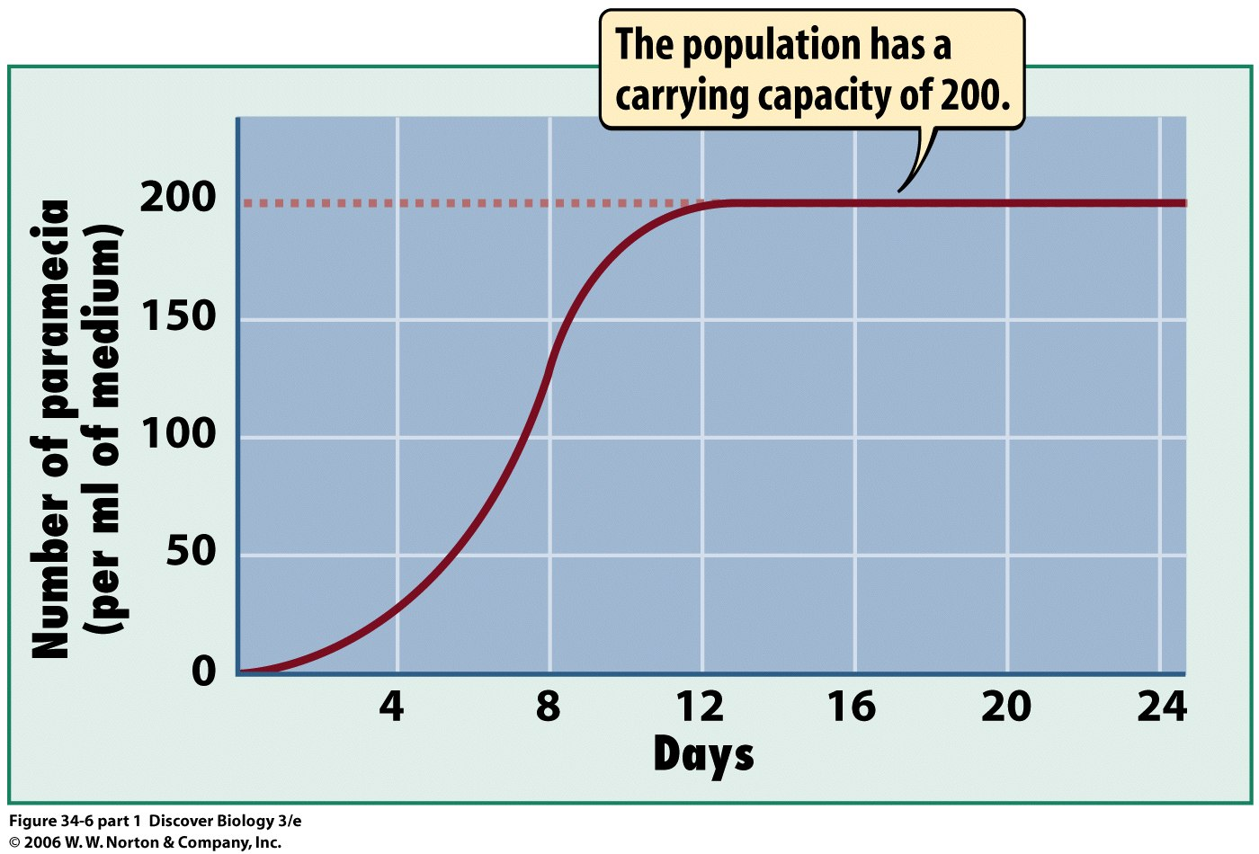
31. Competition for ________________ resources, predation, and __________________ can all affect the size of a population. EX: Dutch Elm Disease – Elm trees are attacked by a _________________ spread by a beetle. Result: many elm tree populations have been decimated by this fungus EX: Pfiesteria- a toxic ____________________ dinoflagellate associated with ___________________________ and algal blooms.

