Human Impact on Ecosystems Station Differentiation

Watch It! Biodiversity Loss and Population Graphs
Go to https://www.youtube.com/watch?v=spTWwqVP_2s about invasive species and answer the questions below.
1. Why was kudzu originally imported to the US?
2. Why are these invasive species (kudzu, Burmese python) growing out of control?
3. What is a limiting factor? Provide three examples.
4. Provide two ways that invasive species are introduced naturally into an ecosystem.

Go to https://www.youtube.com/watch?v=vCkDxD0DV0Q about the loss of biodiversity and answer the questions below.
1. What are five reasons for the loss of biodiversity?
2. What are three ways that we can define biodiversity?
3. What phrase (mnemonic device) can be used to help you remember the reasons for biodiversity loss?
4. What is the sixth extinction? What do scientists believe is the cause?
5. Which species is the most at risk for extinction?
6. List and explain at least two ways that we can preserve biodiversity.

Go to https://www.youtube.com/watch?v=rXlyYFXyfIM about population growth, and answer the questions below.
1. Why can’t exponential growth continue forever and ever?
2. What is the carrying capacity?
3. What happens to the size of a population if the carrying capacity is exceeded?
4. What is a limiting factor? What effect does it have on population sizes? Stop the video after this point.

Station 2: Graph It! Carrying Capacity, Exponential Growth, and Logistic Growth
Using the graph below, answer the questions.
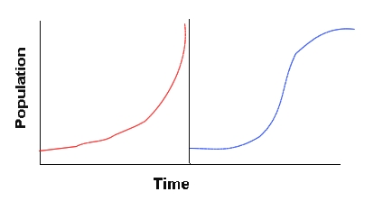
B
A

1. Which graph (A or B) represents exponential growth?
2. Which graph (A or B) represents logistic growth?
3. Identify with a red “X” where on each graph the carrying capacity would be. How do you know?
4. What happens to a population once its carrying capacity has been reached? Why?

Review for Biodiversity Loss and Preservation Quiz

1. What are some characteristics of an invasive species?

2. Explain at least five ways that humans negatively impact ecosystems and decrease biodiversity.

3. Provide at least four reasons why humans be concerned about preserving biodiversity.

4. Explain the difference between exponential and logistic growth. Why is carrying capacity not found on an exponential growth graph?

5. What are limiting factors? Provide two examples.

6. Provide at least two ways humans can preserve biodiversity.

