Lipids Graphic Organizer

Composed of LIPIDS- fats, oils, waxes Monomer
___________ ________________ + _____________________
(EX: __________________________________)
Two Types
Function

_________________ ___________________ 4. ________________________________
Structure: Structure: (EX: ___________________)
_________________ ___________________ 1. ______________________
_________________ ___________________ ________________________ 3. ___________________________
(EX: _________________________)
Is a Is a
_________________ ___________________
at room temperature at room temperature 2. Makes up _______ ____________________
(EX: ___________________________)
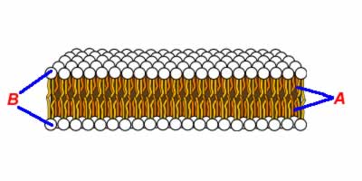
Found in: ________ Found in:___________
_________________ __________________
Saturated | Solid | Long term energy storage | Glycerol + 3 fatty acids
Animal products | Whale blubber | Fearing | Doesn’t hold max # of H atoms | Phospholipid Bilayer
Holds max # of H atoms | Hydrophilic | CHo | Loving | Insulation
Unsaturated | Steroids | Cholesterol | Liquid
Plant oils | Hydrophobic | phospholipids | Cell membrane

____________________
“Water _____________”
Fatty acid tails

________________
“Water_________”
Phosphate heads

C _________________
_________________

