Lipids Guided Notes
1. Lipids are made mostly from __________________ and ______________________. They are ___________________________ and don’t dissolve in water (insoluble). Lipids are composed of _______________________ + _________________ ______________ monomers. The most common lipids are __________, _________, and _______________.
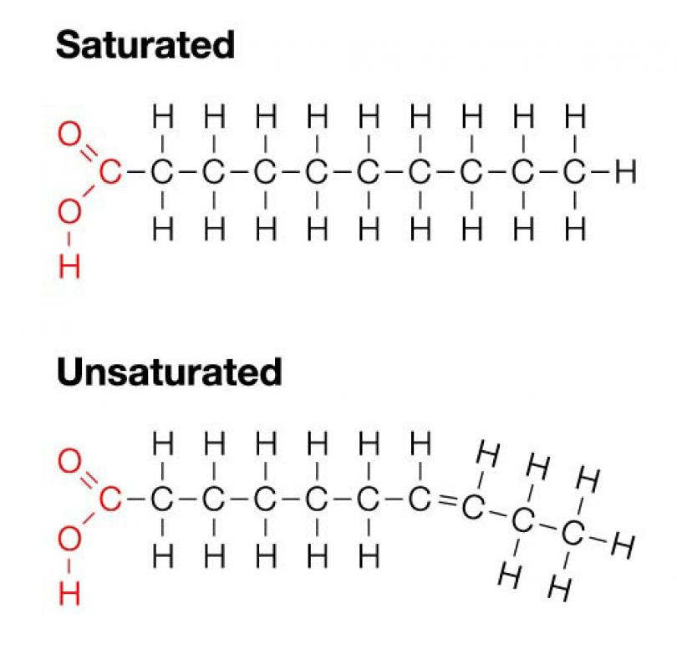
2. There are two types of lipids: ______________________ and ________________________. The difference between saturated and unsaturated fats is that saturated fatty acids contain no ________________ bonds between the carbon atoms. Saturated fats get their name because they contain the _______________________ number of hydrogen atoms (saturated with hydrogen). Unsaturated fatty acids have ______________ bonds existing between carbon atoms.
3. Saturated fats are found in ________________ products like _______________, whole ________, ice creams, and fatty meats. They exist as a _____________ at room temperature. Saturated fats also tend to increase the amount of _______________________ in your body, which also increases your risk for heart attack and stroke by clogging ________________________.
4. Unsaturated fats are found in ____________ products like canola oil, avocados, & nuts. They tend to be a ____________ at room temperature, and unsaturated fats raise the level of good ____________________ in your body.
5. Different types of lipids have different functions. Fats/Oils provide ________ term energy storage, __________________, and _________________________. Phospholipids function to make cell _______________________, _____________________ make hormones (which are chemical messengers), and waxes provide ________________________.
6. Fats & Oils (also called ______________________________) provide _______ term energy storage, because fat has ________________ the calories of carbohydrates. One gram of fat = ______ cal, whereas one gram of sugar= 4 cal. The enormous energy is found within the hydrocarbon tails of the fatty acids.
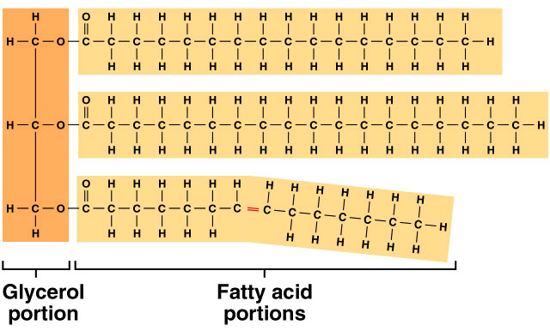
7. Body fat functions to store __________________ and helps insulate and _________________ the organs. Excess ___________________ not burned/used up is converted to fat. Sea mammals rely on fat to keep them ______________.
8. Lipids also function to form cell membranes. Glycerol contains only _____ fatty acids (not 3 like fats and oils). The third fatty acid is replaced by a __________________________ molecule.
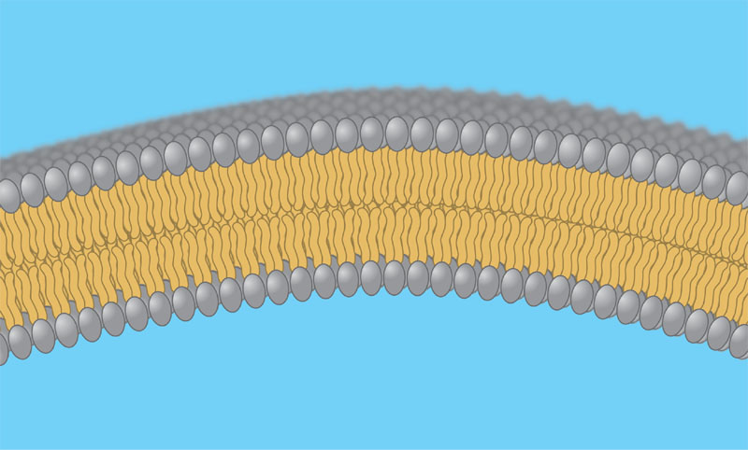
9. The resulting molecule is called a _______________________. The phosphate molecule forms a ____________________ (water loving) head, while fatty acid molecules make up ______________ tails.
10. These phospholipids create the ______________________ of cell membranes. There are two layers of phospholipids. The _____________________ face out to interact with water, while the _____________ tails make up a middle layer that repels water. Phospholipids separate the ___________________ of the cell from its surrounding environment.
11. Cholesterol is a lipid made of four fused (connected) rings of _______________, and is a component of the cell membrane that increases the integrity (____________________) of the membrane.
12. Steroids are lipids that act like hormones. _____________________ is used to make steroids. Hormones are _____________________ messengers that are produced in one part of the body and then travel to and cause changes in _______________________ part of the body. Hormones control: ________________, development, ____________ function, sexual function, the way our bodies use food, the reaction of our bodies to emergencies, __________________. Examples of hormones include _________________ and ________________________.
13. Waxes are lipids that act to repel ___________. A waxy layer is often found on the surface of leaves…why? __________________________________________________________________________________________
Waxes are also found on animal hair to keep it ______________ (bendable), and are found on the feathers of water birds to prevent them from becoming _____________________ (waterproofing).
14. The __________________ spot test is done to test for the presence of lipids. A substance is placed on a brown paper bag. The residue from the substance is allowed to dry, and if a lipid is present a _____________________ spot will be left behind.

