Meiosis Guided Notes

- Organisms that _____________________ sexually are made up of ______ different types of cells.
  - Somatic Cells are “____________” cells and contain the normal number of chromosomes - called the “________________” number (the symbol is ______). EX: skin cells, brain cells
  - Gametes are the “_________” cells and contain only __________ the normal number of chromosomes - called the “_____________” number (the symbol is ________). Sperm cells and ova (eggs) are gametes.
n = number of chromosomes in the set… so….2n means 2 chromosomes in the set…. Polyploid cells have more than two chromosomes per set… example: 3n (3 chromosomes per set)
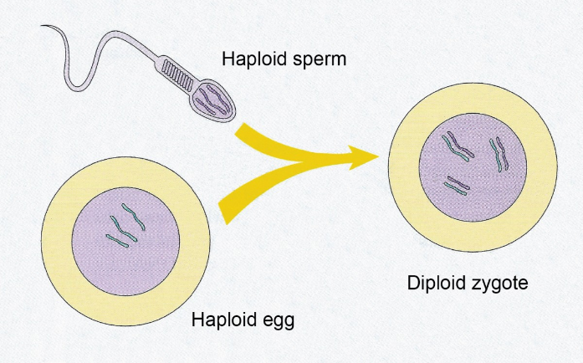
- The ____________ gamete is the sperm. The _________________ gamete is the ovum.
- Fertilization, the joining of the _______________ and _________________, results in the formation of the ______________________ (fertilized egg).
- If an organism has the ________________ number (2n) it has a matching pair of _____________________ ___________________________ for each chromosome number. One of the homologues comes from the _________________ (and has the mother’s DNA) and the other homologue comes from the ___________________ (and has the father’s DNA). Most organisms are _________________. Humans have _______ sets of chromosomes, therefore humans have __________ total chromosomes. The diploid number for humans is 46 (46 chromosomes per cell).
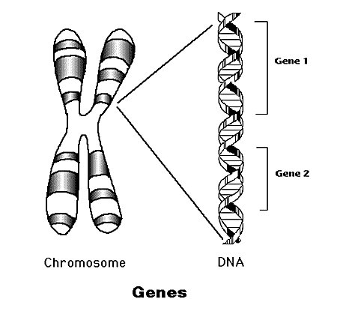
- Genes are located on ________________________. ________________ are alternate forms of a gene. EX: The gene for eye color is on a chromosome, it can have several different alleles: blue, brown, green
- Homologous chromosomes are ____________ of chromosomes (maternal and paternal) that are similar in ____________ and _____________. Homologous pairs (_______________) carry genes controlling the same inherited traits. Each ___________ (position of a gene) is in the same position on homologues. Humans have _______ pairs of homologous chromosomes.
22 pairs of autosomes
1 pair of sex chromosomes
- Remember that homologous chromosomes may not be identical because one comes from the mother and one from the father. Humans have 23 sets of ____________________ chromosomes. Each homologous set is made up of 2 homologues.
- Autosomes code for most of the offspring’s ______________. In humans the “________________” are sets 1 – 22.
- The sex chromosomes code for the _________ of the offspring. If the _________________ has two “X” chromosomes it will be a female. If the offspring has one “X” chromosome and one “Y” chromosome it will be a _____________. In humans the “sex chromosomes” are the ________ set.
- ______________ is the process by which ”_________________” (sex cells) , with half the number of chromosomes, are produced. During Meiosis diploid cells are reduced to haploid cells
Diploid (2n) → Haploid (n)
If meiosis did not occur the ___________________ number in each new generation would _____________ and the offspring would die.
- Meiosis is two _______ _________________ (called meiosis I and meiosis II) with only one _________________ of chromosomes.
- Meiosis in males is called ___________________________ and produces _____________. Meiosis in females is called ________________________ and produces ___________.
- Interphase I - Similar to ____________ interphase. Chromosomes replicate (S phase). Each duplicated _______________ consists of two identical sister _________________ attached at their ______________________. Centriole pairs also replicate.

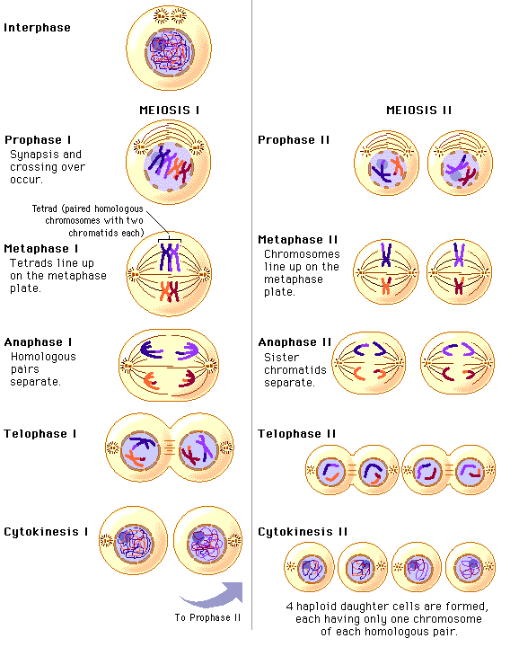
Stages of Meiosis
- Meiosis I (four phases)
Cell division that reduces the ______________________ number by ____________.
Four phases:
a. prophase I
b. metaphase I
c. anaphase I
d. telophase I
- Prophase I
  - Longest and most __________ phase. 90% of the meiotic process is spent in Prophase I.
  - Spindle fibers form, centrioles move to the poles and nuclear envelope dissolves.
  - Chromatin condenses into replicated chromosomes ( 2 ___________ _________________).
  - As homologous chromosomes condense, ________________ occurs: homologous chromosomes come together
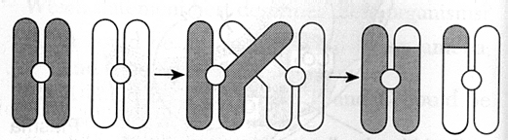
- During synapsis (Prophase I) “____________ ___________” occurs. Crossing over is one of the two major occurrences of Meiosis (The other is non-disjunction). During crossing over segments of _____________ break off and reattach to the paired homologous chromosome. This leads to greater genetic ___________________!
- Metaphase I
  - Spindle fibers attach to the _________________________ of each homologous chromosome
  - Pairs of _______________________ chromosomes line up at the equator of the cell.
  - This is a major difference between Meiosis and Mitosis. Recall in Mitosis, individual chromosomes line up at the equator.
  - Independent _______________ occurs:
i. Orientation of homologous pair to poles is ________________.
ii. Leads to greater genetic __________________

- Anaphase I
  - ______________________ chromosomes separate and move towards the poles.
  - Sister chromatids remain attached at their ______________________.

- Telophase I
Chromosomes uncoil and spindle fibers break down. Nuclear envelopes form around the DNA at each pole creating 2 __________________.
Each pole now has one of the 2 homologous chromosomes consisting of 2 sister chromatids. The sister chromatids may not be identical due to ___________________ _______________.
- Cytokinesis occurs and two haploid daughter cells are formed. Because there is only one copy of each chromosome at each pole, the chromosome number is said to be ______________________.
- Meiosis II
  - No interphase II (or very short period call interkinesis - no _________ __________________)
  - Meiosis II is similar to _______________
- Prophase II
  - Same as prophase in ___________________

- Metaphase II
  - Same as _____________________ in mitosis

- Anaphase II
  - same as anaphase in mitosis
  - _________ _________________ separate

- Telophase II
  - Same as telophase in mitosis
  - _________________ form
  - Cytokinesis occurs
  - Remember: four haploid daughter cells are produced.
  - ______________________ = sperm or egg
- Non-disjunction is one of the two major occurrences. The other is ________________ __________. _____-______________ is the failure of homologous chromosomes, or sister chromatids, to _______________________ during meiosis. Non-disjunction results in the production of ___________________ with abnormal chromosome number. An abnormal chromosome number (abnormal amount of DNA) is ___________________ to the offspring.

- Non-disjunction is the failure of homologous chromosomes, or sister chromatids, to separate during ___________________________ . Non-disjunction results in the production of zygotes with abnormal chromosome numbers…… remember…. An abnormal chromosome number (abnormal amount of DNA) is damaging to the offspring.
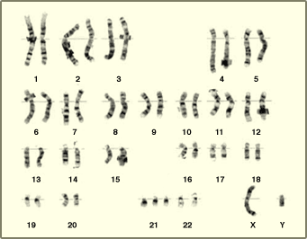
- Non-disjunction is displayed in one of two fashions. The first is called ___________________, the second is called ____________________. If an organism has Trisomy 18 it has three chromosomes in the 18th set, Trisomy 21…. Three chromosomes in the 21st set. If an organism has Monosomy 23 it has only one ______________________ in the 23rd set.

- Common Non-disjunction disorders
  - Down’s Syndrome – Trisomy 21
  - Turner’s Syndrome – Monosomy 23 (X)
  - Kleinfelter’s Syndrome – Trisomy 23 (XXY)
  - Edward’s Syndrome – Trisomy 18

- An _________________________ is a procedure a pregnant woman can have in order to detect some genetics disorders such as non-disjunction.

- One of the ways to analyze the amniocentesis is to make a ____________________. What genetic disorder does this karyotype show?

_________________ 21 - Down’s Syndrome

