Nucleic Acids Guided Notes

1. Nucleic acids are composed of __________________, __________________, __________________________, __________________, and ________________________ (CHONP). They are made up of monomers called ____________________________.
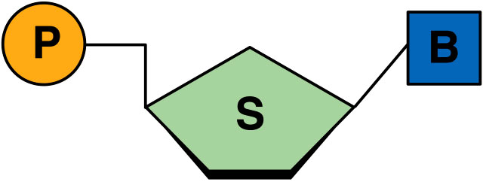

P= Phosphate group
S = a 5 carbon sugar (either ribose or deoyribose)
B = Nitrogen Base
2. There are two main functions of nucleic acids:
(1) Store ____________________ information
(2) _________________ genetic information
3. There are two main types of nucleic acids:
(1) _____________________ acid (RNA)
(2) ________________________ acid (DNA)
4. RNA (ribonucleic acid) contains a different sugar group (________________) than DNA. It has a __________________ strand of nucleotides that forms a single _______________. It functions to ___________________ information from the DNA to the ribosomes. RNA carries a protein recipe to the ribosomes, structures in a cell that make ______________________.
5. DNA (deoxyribose nucleic acid) contains the sugar ____________________. It has ______ chains of nucleotides held together by bonds. It forms a _______________ helix structure. DNA functions to _______________ hereditary information. It also provides recipes for the proteins that are made, and is found in the cell’s ____________________.
6. Comparison of DNA vs RNA:
DNA | RNA
____________________ Stranded | ______________________ Stranded
Sugar: __________________________ | Sugar: __________________________
Includes Nitrogen Bases: ___________________ | Includes Nitrogen Bases: ___________________

