PASSIVE CELL TRANSPORT GUIDED NOTES
1. Recall that the _____ _________________ controls what enters and what leaves the cell. It also provides protection and support.
2. The Cell Membrane is also called the “___________________ Mosaic Model”. The outer membrane of the cell is a ____________ bilayer (Fluid Movement)______ layers of fat. Lipids provide a ___________________ structure and barrier between the cell and its surroundings. The cell membrane also has _______________ embedded in the membrane that act as _____________________ to bring substances into and out of the cell.
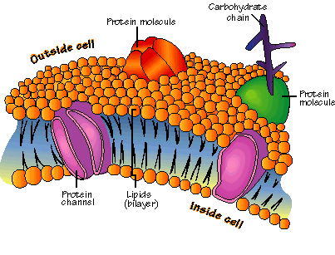
3. All cells must remain in a state of _______________________. Cells must constantly bring substances into and out of the cell to maintain a dynamic _________________ with the environment they live in!! If a substance can pass through the membrane, it is said to be ___________________. If a substance cannot pass through the membrane, it is said to be ________________________. Most biological membranes are _____________ ___ ____________________, which means that some substances can pass through and some cannot.
4. A __________________ is a mixture of two or more substances. The __________________ is the substance doing the dissolving (present in the greater amount). The _________________ is the substance being dissolved (substance present in the smaller amount). When we say something is ___________________________, we are talking about how much solute is dissolved in a given amount of solution. One of the most important functions of cells is to _____________________ how dissolved molecules get into and out of the cell through the membrane.
5. There are two main ways that cells can transport substances:
(1) ___________________ transport – this type of transport allows molecules to come into and out of the cell without requiring ______________ to bring them in and out
(2) ________________ transport – cell must use _________________ to bring the molecule inside or out
6. In a solution particles are constantly ___________________. They collide with each other and spread out _________________. ____________________ is when the particles move from a more concentrated area to less concentrated area. (EX: spray perfume in one part of the room, eventually you will smell the perfume in all parts of the room; it diffuses throughout). When the concentration of the solute is the same throughout a system, the system has reach ________________________.
7. Since diffusion depends on __________________ particle movements, substances can travel through the membrane without requiring the cell to use ________________. Even when equilibrium is reached, particles will continue to flow back and forth across the membrane to maintain ______________________.
8. ____________________ is the diffusion of water through a membrane. The movement of water is controlled by a ______________________ __________________. In biology, a gradient results from an _______________ distribution of ions (charged particles) across the cell membrane. When this happens, solutes move along a concentration gradient from the area of _____________________ concentration to the area of ____________ concentration. ____________________ works when solute particles move with the gradient; _________________ occurs when water moves from an area of high water concentration to an area of low water concentration.
9. We can predict where water will move in three types of solutions:
(1) hypertonic solution
(2) hypotonic solution
(3) isotonic solution
10. A _____________________ _____________________ occurs when the concentration of the solution is greater than the concentration of the cell. Because the concentration gradient is greater outside the cell (more solute than water), water will move out of the cell and the cell will ____________________ (REMEMBER: SALT AND SUGAR SUCK!)
11. A __________________ ____________________ occurs when the concentration of solution is lower than the concentration of the cell. Because the concentration gradient is lower _________________ the cell (less solute than water), water will move ___________ the cell and the cell will ________________.
Remember: hypO is low, the cell swells like an O
12. Isotonic solutions occur when the concentration of the solution is _____________ to the concentration of the cell. Osmosis does occur, but the cell __________ __________ change shape!
13. Predict what happens when:
(1) A salt water plant is placed in a gallon bucket of freshwater. What will happen to the plant cell?

(2) A person is stranded out at sea. Thirsty, she drinks ocean water that has a high salt concentration. What will happen to her cells?

(3) A cell contains 5% solute and is placed in a 17% solution. What will happen to the cell?

