**Photosynthesis Guided Notes**

1. Plant cells trap __________________________________and store it in a usable form in the ____________________________ _______ _________________. ATP is used to make _____________________ **(glucose)**. *________________________________* = process plants use to convert the sun’s energy and build _________________________ or **C6H12O6**

**6CO2 + 6H2O 🡪 C6H12O6 + 6O2**

1. Photosynthesis occurs in the presence of **____________________** and **____________________** (a light absorbing pigment).
2. *_______________:* contains the ____________________ organelle where photosynthesis occurs. ***_______________:*** contains __________ and __________, where water and nutrients move throughout the plant. ***_______________:*** where rate of cell ______________ is the greatest; plants grow from the roots up.
3. Photosynthesis occurs in the __________________________ of plant cells.
4. 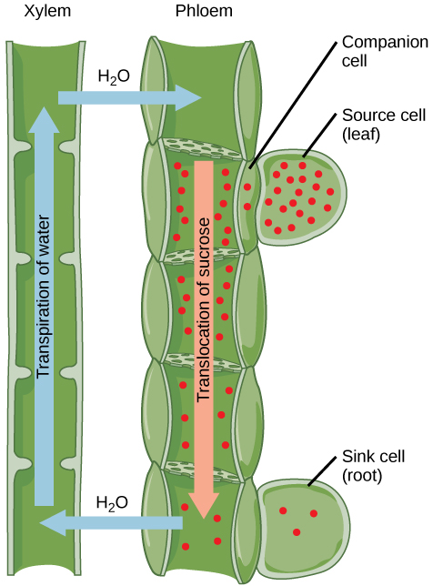**____________________**: pores on the leaves that allow carbon dioxide (CO2) in and __________________ (O2)out during _____________________________________. **____________________ _____________** control the opening & closing of the _________________ (open during the __________ for _______________________ & closed at night). **_____________________________**: loss of water through the ________________________ of leaves.
5. In vascular plants, ***_________________*** takes water and ______________________ from the roots to the rest of the plant (moves up). ***__________________*** carries sugars down to the roots (_____________ ________________).
6. Growth rate is _______________ in the roots, because plants grow from the _____________ up!
7. Factors Affecting the Rate of Photosynthesis

a. _______________________________ of light

Red & blue increase rate of photosynthesis; green decreases rate of photosynthesis

b. Light ______________________

c. ________________________ (within range)

d. _______________ availability

e. ________ concentration

f. ________________ availability

9. **Chlorophyll** = __________________________ that traps the sun’s energy and ________________________ most wavelengths __________________________________ for _______________________________ light

1. 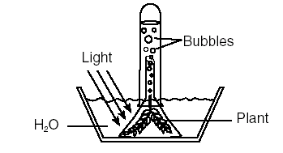Which set of data shows the plant performing photosynthesis at the highest rate? How do you know?
2. What do the bubbles on the right represent?
3. The ________________________ of energy for life on Earth is the ____________________. The only way to get that energy to living things is through _________________.