PROTEINS GUIDED NOTES

1. Proteins include some of the most diverse group of macromolecules (_________________). They contain ___________________, _________________, __________________, and _________________. Examples of proteins include:
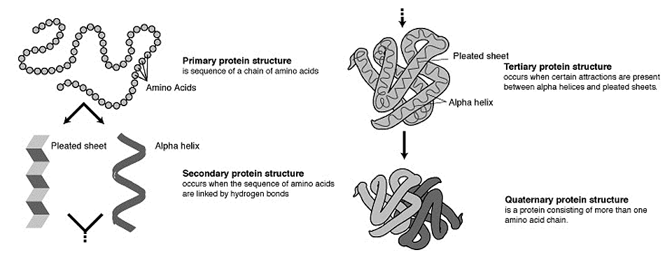
(1) ______________________________
(2) __________________ Proteins
(3) _______________________
(4) __________________ Proteins
(5) __________________
2. Proteins are composed of monomers called ________________ _____________. More than ______ different amino acids exist in nature.
3. Proteins can have up to _________ different layers of organization, and assume a _______________________ shape.
4. Proteins serve many different functions:
1. Muscles provide structural support and motion (____________________ and _____________________)
2. Help fight _______________________ (antibodies)
3. ______________ cell processes (hormones)
4. Transport substances into or out of cells (_____________________________)
5. Structural proteins provide __________________________(keratin and collagen)
6. ___________________ reaction rates )__________________________)
5. Contractile proteins are responsible for _____________________. Examples include _________ and _________________. These proteins are involved in muscle ______________________ and ______________________.
6. Proteins help fight ___________________. _____________________________ are specialized proteins involved in defending the body from __________________ (foreign invaders). They can travel through the bloodstream and are utilized by the immune system to ____________________ and __________________ against bacteria, viruses, and other foreign intruders.
7. __________________ _____________________ are messenger proteins which help to regulate bodily activities and maintain _________________________. Insulin regulates glucose metabolism by controlling the _________________ _________________ concentration.
8. ________________________ proteins are proteins which move molecules from one place to another around the body. Hemoglobin transports ____________________ through the blood.
9. _______________________ proteins are fibrous and stringy and provide support. Examples include __________________ and ______________________. Keratins strengthen protective coverings such as __________, ____________, quills, feathers, horns, and beaks. Collagens provide support for connective tissues such as _____________________ and _________________________.
10. ___________________ are proteins that aid in biochemical reactions. Most chemical reactions require energy to begin. The energy required to start a chemical reaction is called _________________________ energy.
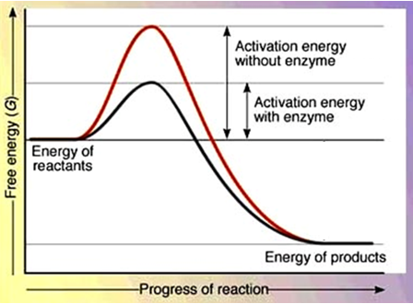
11. Enzymes are _____________________ which reduce the _________________________ _____________________ required for a chemical reaction to occur.
12. Enzymes are often referred to as ____________________ because they speed up chemical reactions. The catalyst does not _______________ during the reaction!
13. Enzymes have an area called an _____________ site. The active site is where the ____________________ reaction occurs.
14. The active site of the enzyme fits with only one type of molecule known as the _______________________. The fact that the active site can only accept ________ type of substrate is known as _________________ specificity.
15. There are two ways enzymes can work to bind to a substrate: (1) ________ and ___________ model, and (2) the ___________________ Fit Model.
16. With the Lock and Key Model, the _____________________ fits into the ______________ site like a key into a lock. The enzyme puts stress on the bond which reduces the amount of _________________ needed to break apart the substrate. The ___________________ of the reaction leave and make the ___________________ available for more substrate.
17. In the Induced Fit model, the ___________________ doesn’t quite fit into the active site. The substrate causes (____________________) the enzyme to change _______________, which allows the substrate to fit into the active site. The enzyme stresses ____________ on the substrate and reduces the amount of _____________________ energy required for the reaction to occur.
18. Enzymes are affected by two main factors:
(1) ____________
(2)______________________
19. Each enzyme functions best within a certain _________ range. For example, the enzyme ________________, which works in your stomach, functions best in a strongly __________________ environment. When the pH changes, the active site __________________ and _________________ enzyme function.
20. Chemical reactions ________________ up as temperature is _____________________, so, in general, reactions will increase at a ________________ rate at ____________________ temperatures. However, each enzyme has a temperature _________________________, and beyond this point the enzyme's _____________________ shape is lost. Boiling temperatures will ___________________ most enzymes.
21. Enzymes often end in the suffix ___________. EX: Amylase - breaks down ______________, Catalase – breaks down H₂O_{2,} DNA polymerase – joins DNA nucleotides to build DNA, Lipase – break apart ________, Lactase – breaks apart ________________ (milk sugar), Protease- breaks apart ________________ molecules.

