Learn Genetics http://learn.genetics.utah.edu/
Directions: go to the following website: http://learn.genetics.utah.edu/content/selection/recipe/ Watch the animation and answer the following questions. Then use this handout to complete the crossword puzzle review.
Recipe for Evolution: Variation, Selection & Time
- The first living thing appeared on earth over
- The describes how the descendants of this first cell have changed over countless generation to produce the of species on our planet today.
- The 3 ingredient of this change are
- The 2 processes that introduce new variation with each generation are
- The 2 processes stated above are always at work creating this in all life forms.
- What controls the genetic variations that are kept and the genetic variations that are eliminated?
- What 3 conditions can eliminate a species. for , and the
- How does natural selection work with regards to genes and what is passed to the next generation?
- If natural selection doesn’t have a goal, what is its purpose?
- Small and gradual changes to influential genes over a long period of time can change a population. What did this generate on our planet?
Now go to the following website: http://learn.genetics.utah.edu/content/selection/misconceptions/ Watch the animation and answer the following questions. Then use this handout to complete the crossword puzzle review.
Things You May Not Know About Evolution
- In the game of evolution you don’t have to be the you just have to be better than your
- Why was moving on land for the first vertebrate a big deal?
- Evolution can modify existing structures but it has to work within the limits of what is
- If both humans and other mammals have a larynx, why is it that these other mammals cannot speak?
- Evolution is not climbing a ladder toward perfection. Why is it advantageous for the ice fish NOT to have red blood cells?
- How does the parasitic tapeworm obtain its nutrients if it has not digestive system?
- How does natural selection maintain the traits needed for survival?
- About how many genes have been preserved over billion years of evolution.
- What do these 500 genes code for?
- If a structure is not used and doesn’t affect an animal’s survival, what happens to genes of that structure?
- What is a theory?
- If evolution doesn’t explain how life began, what does it explain?
- Does the number of chromosome determine an organism’s complexity? Explain
- Explain why evolution is not linear.
Now go to the following website: http://learn.genetics.utah.edu/content/selection/sources/ Watch the animation and answer the following questions. Then use this handout to complete the crossword puzzle review.
Sources of Variation
- How does diversity begin?
- Genes come in with slightly different Each version functions a little differently; for example, two versions of the same gene can produce either brown or blue eyes.
- What is the primary source of variation for all life forms, from bacteria to humans to large giant sequoia trees.
- Mutations are like in the DNA coping process. Common mutations involve miscopying a Some mutations involve
- Mutations that are passed to offspring occur in what type of cells?
- (circle) True or False? We have mutations in our DNA that was not present in our parents.
- Mutations occur at random throughout the . In coding regions, mutations can change the of a protein. In controlled regions (called ), mutations can change the timing, location and level of gene activation.
- Whether a mutation conveys and advantage, disadvantage, or is neutral depends on the organisms’
- What is the second source of variation is called? What does it do?
- In organisms that reproduce sexually, how is recombination accomplished?
- The random processes of mutations and recombination create . The nonrandom process of natural selection acts on this variation.
- What does natural selection ensure regarding favorable variations, harmful mutations and unfavorable gene combinations?
Now go to the following website: http://learn.genetics.utah.edu/content/selection/artificial/ Watch the animation and answer the following questions. Then use this handout to complete the crossword puzzle review.
Artificial vs. Natural Selection
- With the millions of different species on our plant, what is it that these species are competing for?
- What does natural selection favor regarding the millions of different species?
- What is selective breeding or artificial selection?
- What is the goal of natural selection?
- What is the goal of artificial selection?
- Two animals are in the “wild”. One was made through artificial selection while the other through natural selection? Which would one survive? Why? Explain.
- Who has been given credit for the term evolution? Where did he visit and gathered data to support the theory of evolution?
- What animal did he study? What body structure did he study?
- What did he conclude regarding the body structure of the above animal?
Now go to the following website: http://learn.genetics.utah.edu/content/selection/related/ Watch the animation and answer the following questions. Then use this handout to complete the crossword puzzle review.
All Living Things are Related
- Identify evidence that reveal all living things are related?
- What do the similarities suggest about all living things?
- What is a phylogenetic tree?
- What is it about the Tiktaalik that provides evidence of evolution?
- The fossil shows that birds evolved from reptiles because
- Fossils documents how mammals transitioned back to the sea. The was the first animals to have four webbed feet.
- What is a vestigial structure or in the case of the whale, a vestigial leg?
- (circle) True or False? Whales have legs.  - Identify the embryos on the right  - Both humans and fish have a series of pouches near the developing throat. What do these pouches develop into? ____________________  ________________________________________  ________________________________________  How are all speices similar at the molecular level? ______________________________________________________________________________________________________________________  __________________________________________________________ | 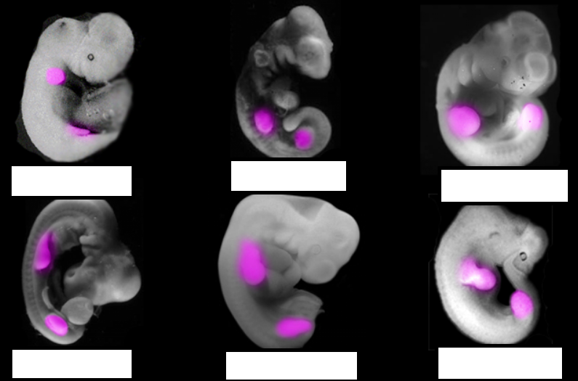
- How many genes do all species have that are the same? .
- How closely related are we to chimpanzees?

