Sodium-Potassium Pump Summary Worksheet
Match the steps of the sodium-potassium pump to the pictures below.
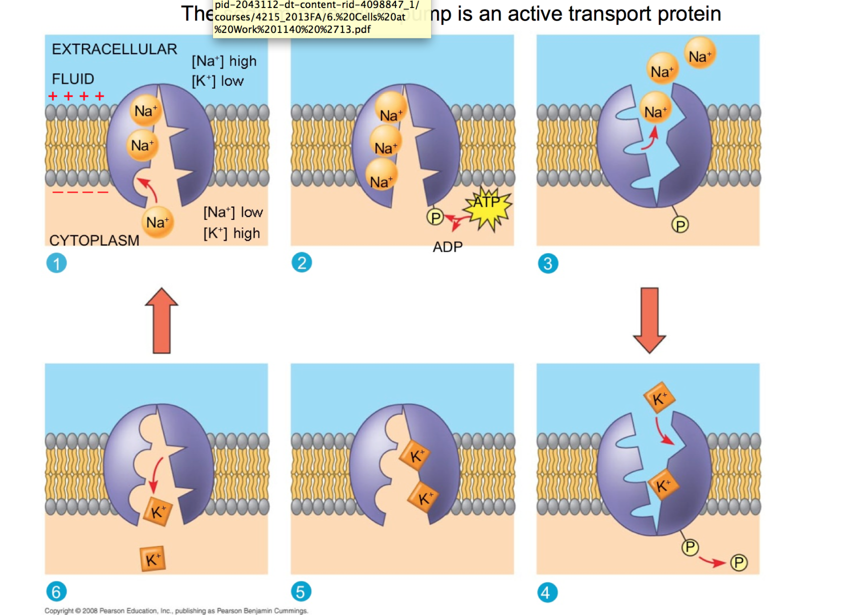

_____ Potassium (K⁺) moves into the cell.
_____ Sodium (Na⁺) binds to the carrier protein, and the protein changes shape.
_____ Energy is required to bring potassium (K⁺) into the cell.
_____ Energy is required to move sodium (Na⁺) out of the cell.
_____ Sodium (Na⁺) moves out of the cell.
_____ Potassium (K⁺) binds to the carrier protein, and the protein changes shape.

