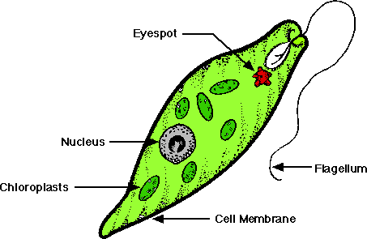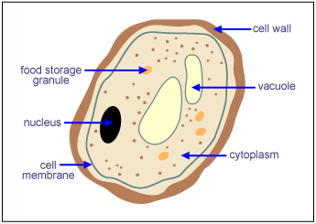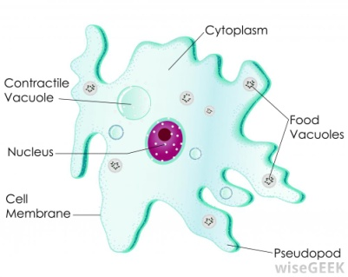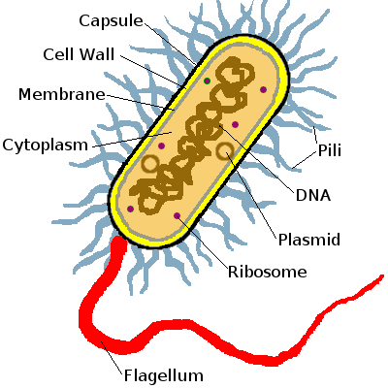

Like bacteria, fungi are a type of microbe.

They cannot make their own food, but eat organisms instead.

Where do you think they store their food?

Fungi cannot move, so how do they get around?

Amoebas have projections called pseudopods. What are they used for?

Do you think amoebas are a type of animal cell or plant cell?

Explain your answer.

Euglena are not plant cells even though they contain chloroplasts.

Why do you think this is?

What is the function of the eyespot?

Some bacteria have ‘tails’ called flagellum. What are they used for?

What do you notice about the DNA of bacteria?

Give an example of a bacterium.

Cell membrane

Cell membrane

Flagellum

Eyespot

Nucleus

Chloroplast

Euglena

Fungi

Nucleus

Cell membrane

Food storage granule

Cell wall

Vacuole

Cytoplasm

Flagellum

DNA

Cell membrane

Cytoplasm

Cell wall

Cytoplasm

Nucleus

Pseudopod

Amoeba

Bacteria

Unicellular Organisms