Unit 4 Review: Cell Transport
- The cell membrane is selectively permeable. This means it allows some things to come in and out.

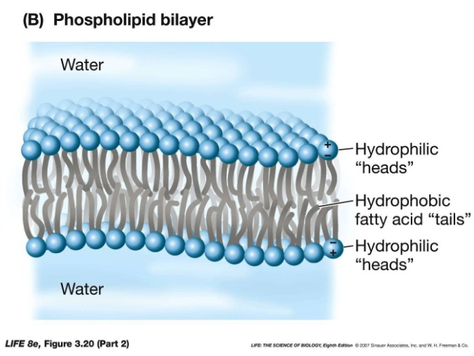
- The main function (purpose) of the cell membrane is to maintain homeostasis. The cell membrane does this by controlling what enters and leaves the cell.

- Hydrophilic = “water loving” phosphate heads
Hydrophobic = “water fearing” fatty acid lipid tails
- Two ways cells can bring substances in or out of the cell:
  - Passive transport
  - Active transport

- Passive transport requires no energy. Particles go “with the flow” or travel with the concentration gradient, from areas of high concentration to areas of low concentration.

- Three examples of passive transport:
  - Diffusion – particles move from high concentration to low concentration EX: perfume odor diffuses
  - Osmosis - movement of water, from area of high water concentration to low water concentration
  - Facilitated diffusion – transport of particles too big to diffuse through membrane from an area of higher concentration to an area of lower concentration. Requires the help of transport proteins.

- Active transport requires energy and moves against the flow or against the concentration gradient from areas of low concentration to areas of high concentration. (ex: Endocytosis, Exocytosis, Sodium-Potassium Pump)
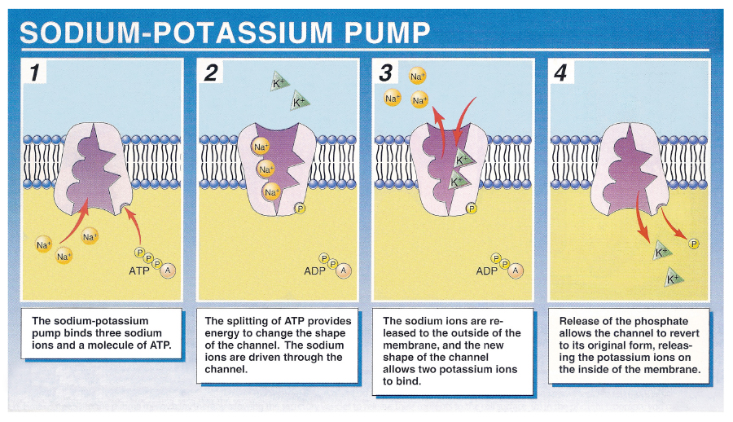
- The human nerve cell sends messages throughout the body using the sodium (Na⁺) –potassium (K⁺) pump.
Four Step Process:
- There is more sodium outside the cell than inside the cell. It requires energy for the cell to pump sodium out AGAINST the gradient. Sodium binds to carrier protein.

- Energy is required to change the protein’s shape and release sodium outside of the cell

- Potassium binds to carrier protein.

4. Energy is required to change the protein’s shape and bring potassium into the cell.

Unit 4 Review: 3 Types of Solution
- HYPeRTONIC Solution –more solute (more concentrated)outside the cell as compared to inside the cell. Water leaves the cell in an effort to dilute the solution outside the cell and reach equilibrium. The cell shrinks due to the loss of water.

- hypOtonic Solution – low concentration of solute outside the cell. Water moves into the cell and the cell swells. **Hypo is low, cell swells like an “O”!**

- Isotonic Solution – concentration outside the cell is equal to the concentration inside the cell. The water moves in and out of the cell but at the same rate, in order to maintain equilibrium. The cell does not change shape.

Remember:

- Solute = what’s being dissolved. Will be present in smaller amounts in the solution.
- Solvent – what’s doing the dissolving. Will be present in larger amounts in the solution.

Determine where the % of solute is greatest. Water will move toward that area. Ex. Greater percentage of solute inside the cell (10%), so water moves into the cell and the cell swells.

Determine the type of solution by looking at the % solute outside the cell (in the solution).
Solution concentration is lower than inside the cell = HYPOtonic
Solution concentration is higher than inside the cell = HYPERtonic
Solution concentration is equal to that inside the cell = ISOtonic

