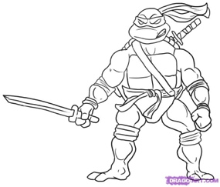Workshop notes 4 : **Mutations**

**Mutation** = _______________________________________ [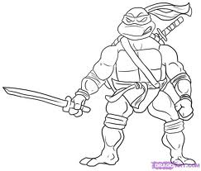](http://www.google.com/imgres?imgurl=http://www.dragoart.com/tuts/pics/9/423/2129/how-to-draw-leonardo-from-teenage-mutant-ninja-turtles-step-5.jpg&imgrefurl=http://www.dragoart.com/tuts/423/1/1/how-to-draw-leonardo-from-teenage-mutant-ninja-turtles.htm&usg=__yF5UWwrWkyP6MNI0fI2E3w6uFFE=&h=681&w=800&sz=54&hl=en&start=147&zoom=1&tbnid=re-Omf1AxVQaYM:&tbnh=127&tbnw=149&prev=/images?q=ninja+turtles&hl=en&biw=1030&bih=572&gbv=2&tbs=isch:1&itbs=1&iact=hc&vpx=119&vpy=64&dur=5917&hovh=207&hovw=243&tx=165&ty=111&ei=osqnTNTXB8H38AbmofD2DA&oei=SsqnTK21DoH58AaVpNWeDA&esq=3&page=10&ndsp=16&ved=1t:429,r:5,s:147) [](http://www.google.com/imgres?imgurl=http://www.dragoart.com/tuts/pics/9/423/2129/how-to-draw-leonardo-from-teenage-mutant-ninja-turtles-step-5.jpg&imgrefurl=http://www.dragoart.com/tuts/423/1/1/how-to-draw-leonardo-from-teenage-mutant-ninja-turtles.htm&usg=__yF5UWwrWkyP6MNI0fI2E3w6uFFE=&h=681&w=800&sz=54&hl=en&start=147&zoom=1&tbnid=re-Omf1AxVQaYM:&tbnh=127&tbnw=149&prev=/images?q=ninja+turtles&hl=en&biw=1030&bih=572&gbv=2&tbs=isch:1&itbs=1&iact=hc&vpx=119&vpy=64&dur=5917&hovh=207&hovw=243&tx=165&ty=111&ei=osqnTNTXB8H38AbmofD2DA&oei=SsqnTK21DoH58AaVpNWeDA&esq=3&page=10&ndsp=16&ved=1t:429,r:5,s:147)

A mutation can occur in an individual ______________

- results in a single changed __________________

- cystic fibrosis a mutation in the protein that makes a type of ion channels in cell membrane

- bacterial _________________ to antibiotics is an example of a beneficial gene mutation

A mutation can occur in a ____________________________

- a chromosome contains many ___________________

- chromosomal mutations affect many proteins

If a mutation occurs in a **________ _________**, the mutation will be passed to offspring

Examples: Down Syndrome, Edward’s Syndrome, Cri-du-Chat

**Causes of Mutations**:

1. Environment: Can be caused by _________________- a physical or chemical cause of mutation. Examples: UV light, radiation, drugs, and benzene.
2. Mutagens are often also ________________________ – anything that causes cancer
3. Can be ______________________, random events.

- mutations occur in 1/100,000 DNA replications (DNA __________________)

* Mutations do not have to be bad (evolution)

**Gene Mutations**:

1. Point Mutations

* A single __________________ is altered. Can change one amino acid in a _________
* Mil**k** – Mil**e**
* GGAC**A**ATCA GGAC**C**ATCA

proline -valine-serine proline-glycine-serine

**\*\*\*ONLY ONE AMINO ACID CAN BE AFFECTED AS A RESULT OF A POINT MUTATION!\*\*\***

2. Frameshift Mutations

* A ____________________ is either inserted or deleted from a _______________.

all of the triplets from the point of _______________ onward will be changed

* An _______________________ occurs when a nucleotide is added to a gene

Example: A nucleotide is inserted

The fat cat ate the rat

The f**a**a tca tat eth era t

-the extra nucleotide *_____________* all of the triplets that follow

* A ______________________ occurs when a nucleotide is removed from a gene.

Example: A nucleotide is __________________

The fat cat ate the rat

Thf atc ata tet her at

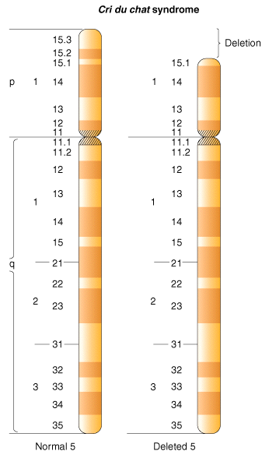**Insertion**

* GGA-CAA-TCA GCG-ACA-ATC-A

proline -valine-serine arginine-cysteine-stop

**Deletion**

* GGA-CAA-TCA GGA-AAT-CA

proline -valine-serine proline-leucine

Example:

Cri du chat syndrome

* Due to a ______________ of part of the short arm of chromosome 5
* Occurrence: 1/50,000 births
* Crying babies sound like cats; mental disability
* Death by about 4 years

**Chromosome Mutations**

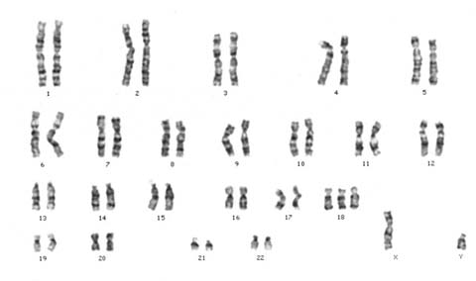**Karyotype** = chart of metaphase ___________________ pairs arranged according to length and location of the centromere

Used to pinpoint unusual chromosome ______________ in cells

Nondisjunction

During meiosis, the homologous chromosomes fail to __________________ properly

This can result in two types of chromosomal ____________________:

(a) _____________________ (have an extra set of chromosomes)

(b) _____________________ (missing one set of chromosomes)

[**Edward’s syndrome (trisomy 18)**](http://www.trisomy.org/)**:**

**Occurs in 1:6000 or 1:8000 live births; very few survive birth.**