Genetic Engineering Notes
Genetic engineering: changing the ______ in living organisms to create something _____.
These organisms are called _____________ _______________ ________________(GMO) or ________________ ______________; since genes are transferred from one organism to another
Example:_______________________________________
Genetically modified organisms are called ____________ ________________; since genes are transferred from one organism to another.
Some genetic engineering techniques are as follows:
- Artificial selection
- ________________________
- _________________________
- _______________________
- __________________
- _____________________
- ____________ __________________: analyzing DNA
1. Artificial selection: breeders choose which _____________________ to mate to produce offspring with desired _____________.
•They cannot control what _____________ are passed.
•When they get offspring with the desired _________________, they maintain them by continuing to _____________ them.
Three types of artificial selection:
A. ____________________ breeding
B. ____________________
C. ____________________
A. Selective breeding: when animals with desired _______________________ are mated to produce offspring with those desired __________________. Passing of important _____________________ to next generation.
•Example: Champion race horses, cows with tender meat, large juicy on a tree.
•People breed dogs for _________________ purposes. Dachshunds were once bred to ____________ badgers and other burrowing animals. They had to be ____________ to fit into the animal’s hole in the ground.
Benefits of selective breeding:
- Angus cows are bred to ________________-- muscle mass so that we get more meat.
- Egg-Laying Hen - produces more _______________ than the average hen
B. Hybridizations: two individuals with _________________ characteristics are ______________________ to produce the best in both organisms.
•Example: Luther Burbank created a disease _________________ potato called the Burbank potato. He crossed a disease __________________ plant with one that had a large food __________________ capacity. Result: disease resistant plant that makes a lot of potatoes.
C. Inbreeding - breeding of organisms that are _______________________ similar to maintain desired traits.
•Dog breeds are kept “pure” and __________________ from other breeds. Risk: Since both parents have the same ______________, the chance that a baby will get a ________________ genetic disorder is high. Risks: cataracts, hip dysplasia (joint deformities)
Variation: difference between individuals of a ________________. Variation occurs as a result of combinations of different _______________ in organisms. Results in: different skin color, hair color, eye color, height, etc
Inbreeding decreases ________________ variation because no new ____________ are introduced.

2. Cloning: creating an organism that is an _______ ______________ copy of another. There are human clones in our school. ________________ twins are naturally created clones.
_____________: group of cells or organisms that are genetically identical as a result of ______________ __________________
They will have the same exact ________ as the parent.
How is cloning done?
- A _______________ cell is removed from a __________________ organism.
- An entire _________________ is grown from that cell.
- Remember one cell has all the ____________ needed to make an entire organism.
- Each _____________ in the body has the same ___________, but cells vary because different genes are turned on in each cell. This is __________________________!
What is the name of the first mammal clone?

____________ was the first mammal cloned. (1996). She had the same exact DNA as her mother and had no ___________________. Cloning is a form of ______________ reproduction, since there is only one genetic parent.
- Remember: Eggs are _________________. Haploid: half the chromosomes, 23 in humans
- Body cells are ____________________: Diploid: two sets of chromosomes, one from mom and one set from dad 46 in humans.
How could you clone a human?
Step 1: An _______________ is removed from a female human. Eggs are _____________: 23 chromosomes. The __________________ of the egg is removed and is thrown away.
Step 2: A _____________ cell is removed from another person. The ________________ of the body cell is removed
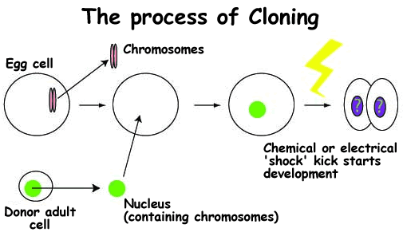
Step 3: The nucleus of the ____________________ body cell is put into the egg. This egg no longer needs to be fertilized since it has all _____________ chromosomes.
Step 4: The _____________ is then charged with electricity to start ____________________.
Step 5: It’s then put into a ______________ mother so it can grow. It’s going to be ________________ __________________ to the parent of the body cell. But it will be a baby. Plants and animals can be ________________.
What are the benefits of cloning?
- You can make ________ copies of organisms with strong traits.
- Increase __________ supply.
- ___________ purposes: clone organs for _______________.
- Bring back or stop ________________ from going _______________.
What are the risks of cloning?
- __________________ genetic diversity.
- If one of your clones gets a ___________, they all get it. Same immune system.
- Inefficient: high failure rate of ______%+
- _____________________

Since Dolly, cats and other organisms have been cloned. Why did the cat that was cloned not have the same fur color as the mother?
- Environment CAN affect how genes are ______________ (phenotype). ____________ twin studies: identical twins raised apart in separate homes/environments showed different _________________
- We can change the ______________ (color) of hydrangea blooms by changing the acidity of the soil:
  - ________________ soil produces pink blooms. ______________ soil produces blue blooms
Transgenic Organisms
Trans: means _______________Genic: refers to ______________
Transgenic Animals: Why make transgenic organisms (animals and plants)?
It’s a way to improve amount of food when human population continues to increase! A.________________ ________: gene inserted to increase milk production.

B. Spider goat: gene from spider inserted into goat. Goats make silk of the spider _________ in their milk. __________________, yet stronger than steel. Used in bullet proof jackets.

C. Glow-in-the-dark cats Scientist used a _____________ to insert DNA from jellyfish. The gene made the cat produce a __________________________ protein in its fur.

Transgenic bacteria: __________________ inserted into bacteria so they produce things humans need. For example: insulin and clotting factors in blood are now made by ______________.
Transgenic plants: plants are given _______________ so they meet human needs.
a. Venomous cabbage
gene from a ________________ tails inserted into cabbage. Cabbage now produces that chemical. Why? Limit ______________________ use while still preventing insects from damaging crops. Corporations state the ________________ is modified so it isn’t harmful to humans.
b. Banana vaccines
_________________ is injected into a banana, the virus DNA becomes part of the plant. As the plant grows, it produces the virus __________________ — but not the disease part of the virus. When people eat a bite, their immune systems create _______________________ to fight the disease — just like a traditional vaccine. Vaccines for hepatitis and cholera
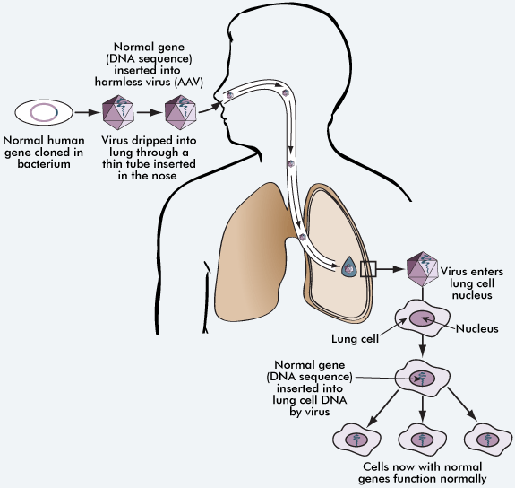
Gene therapy: when disease-causing genes are ______ out and a ________ gene is inserted. ____________ ______________ are used to cut out bad genes. ________________ (vector) are used to insert good genes.
Human Genome Project
- Gene therapy could work thanks to the Human Genome Project (2001), a federally funded effort to completely ________ and _________________ the entire human genome.
- Approximately 35,000-40,000 genes on 46 chromosomes have been mapped to specific locations on particular ___________________
Cystic Fibrosis Gene Therapy
- Experimental trials for ________ ____________ are relatively new due to potential lethal side effects. EX: Cystic fibrosis and Severe Combined Immunodeficiency (________________)
Severe Combined Immunodeficiency
- Diagnosed in 40 to 100 babies every year in the US. Results in the inability of the body to fight off _______________. Gene therapy has cured 8 of 10 children with this disease as of January 2009

